AVOGERA HEALTH FACILITY
S/N | Name of Facility | Picture
1 | Avogera Health Facility | 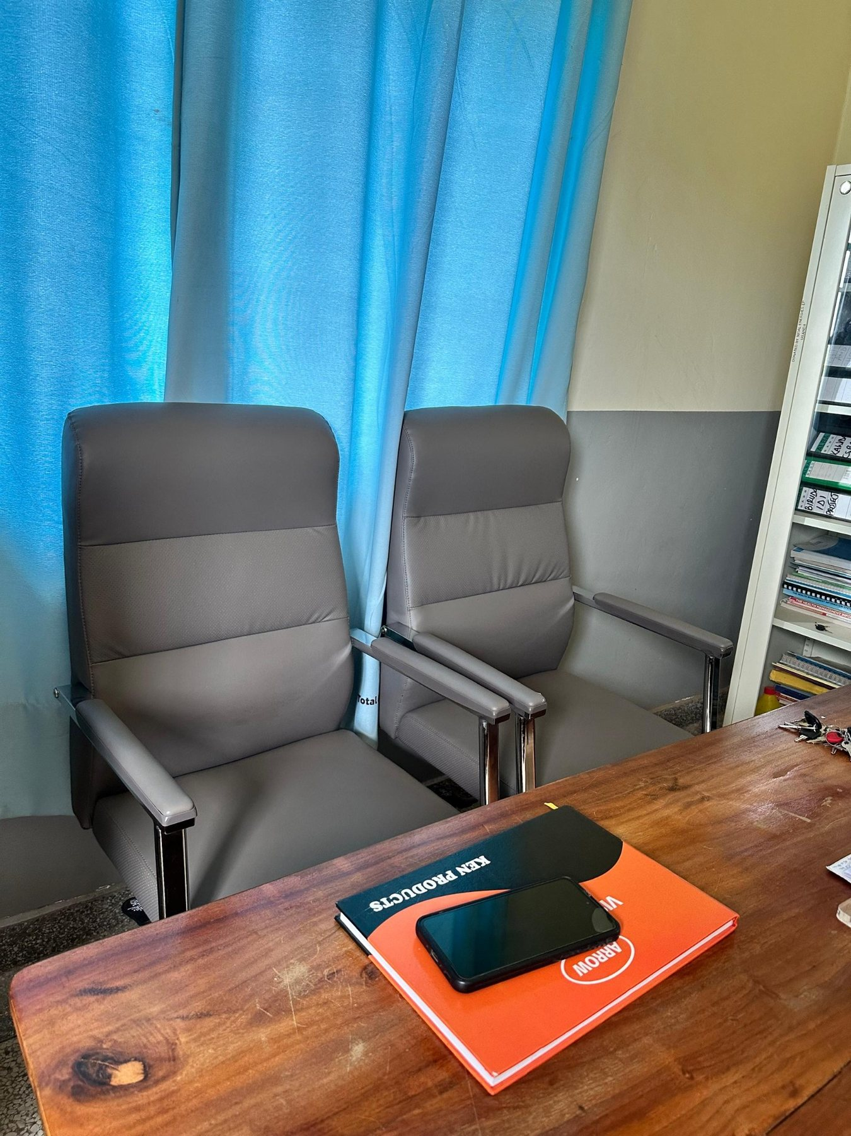
2 | Avogera Health Facility | 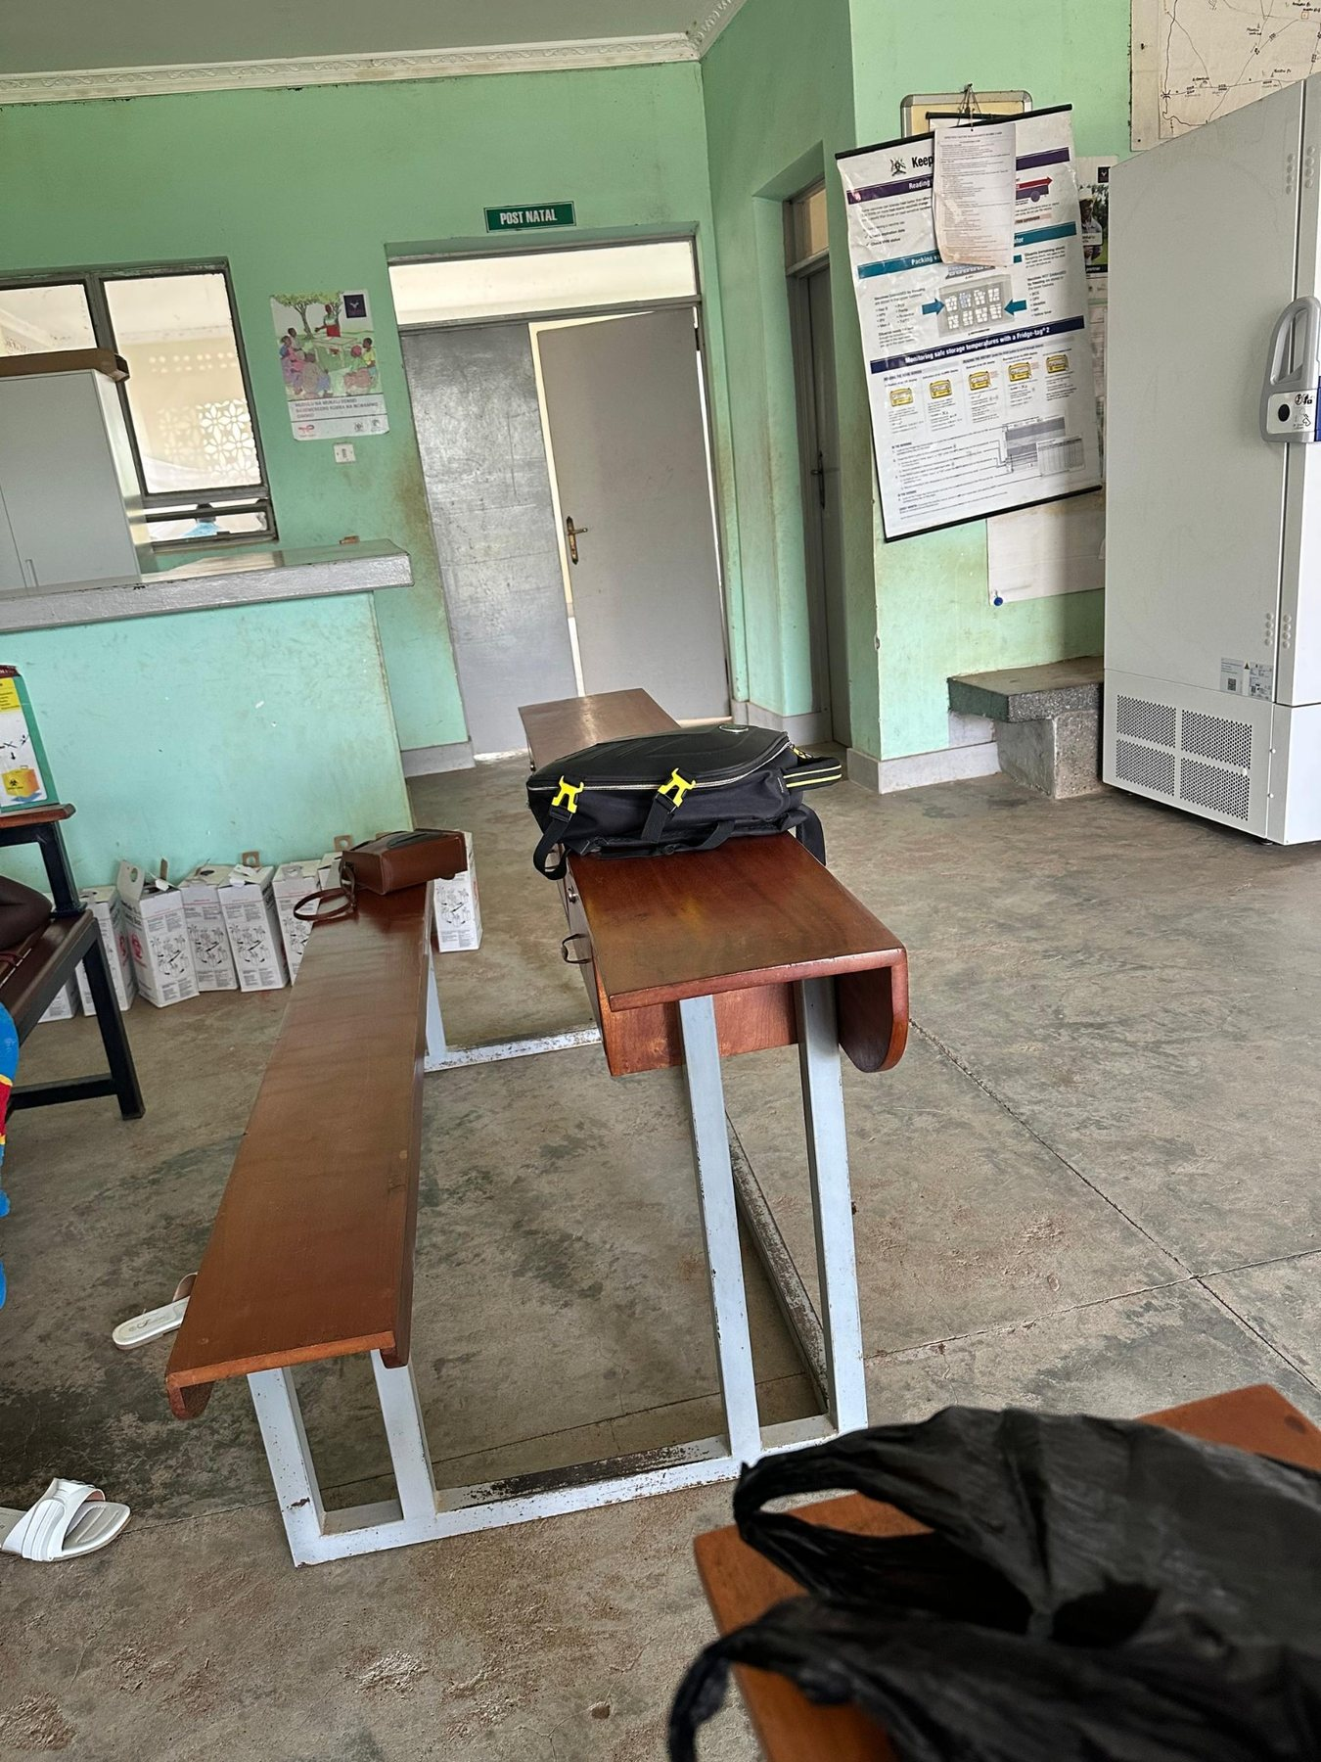
3 | Avogera Health Facility | 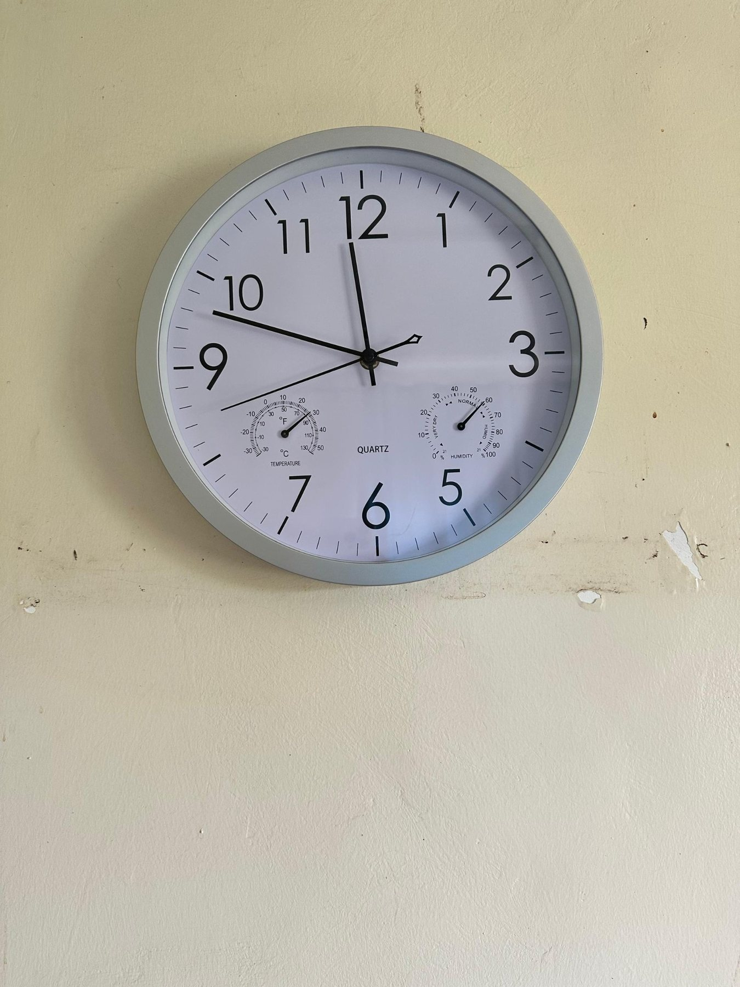
4 | Avogera Health Facility | 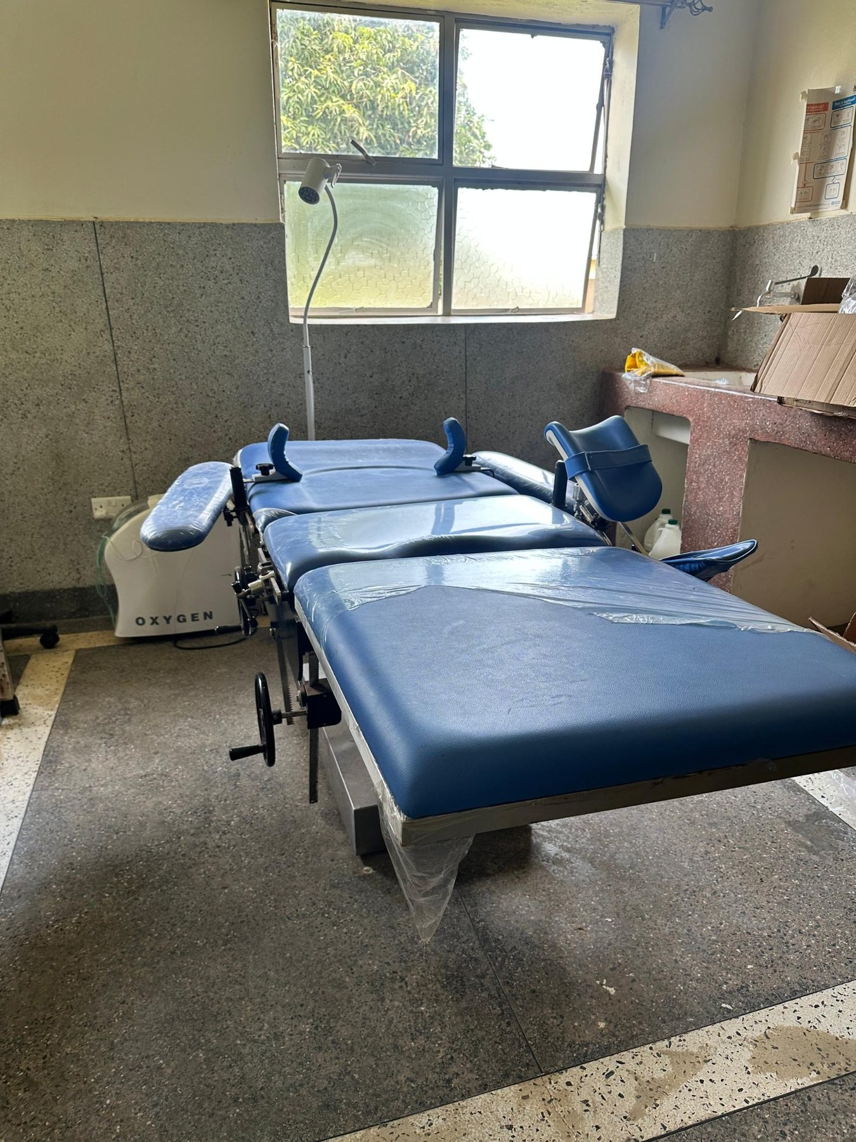
5 | Avogera Health Facility | 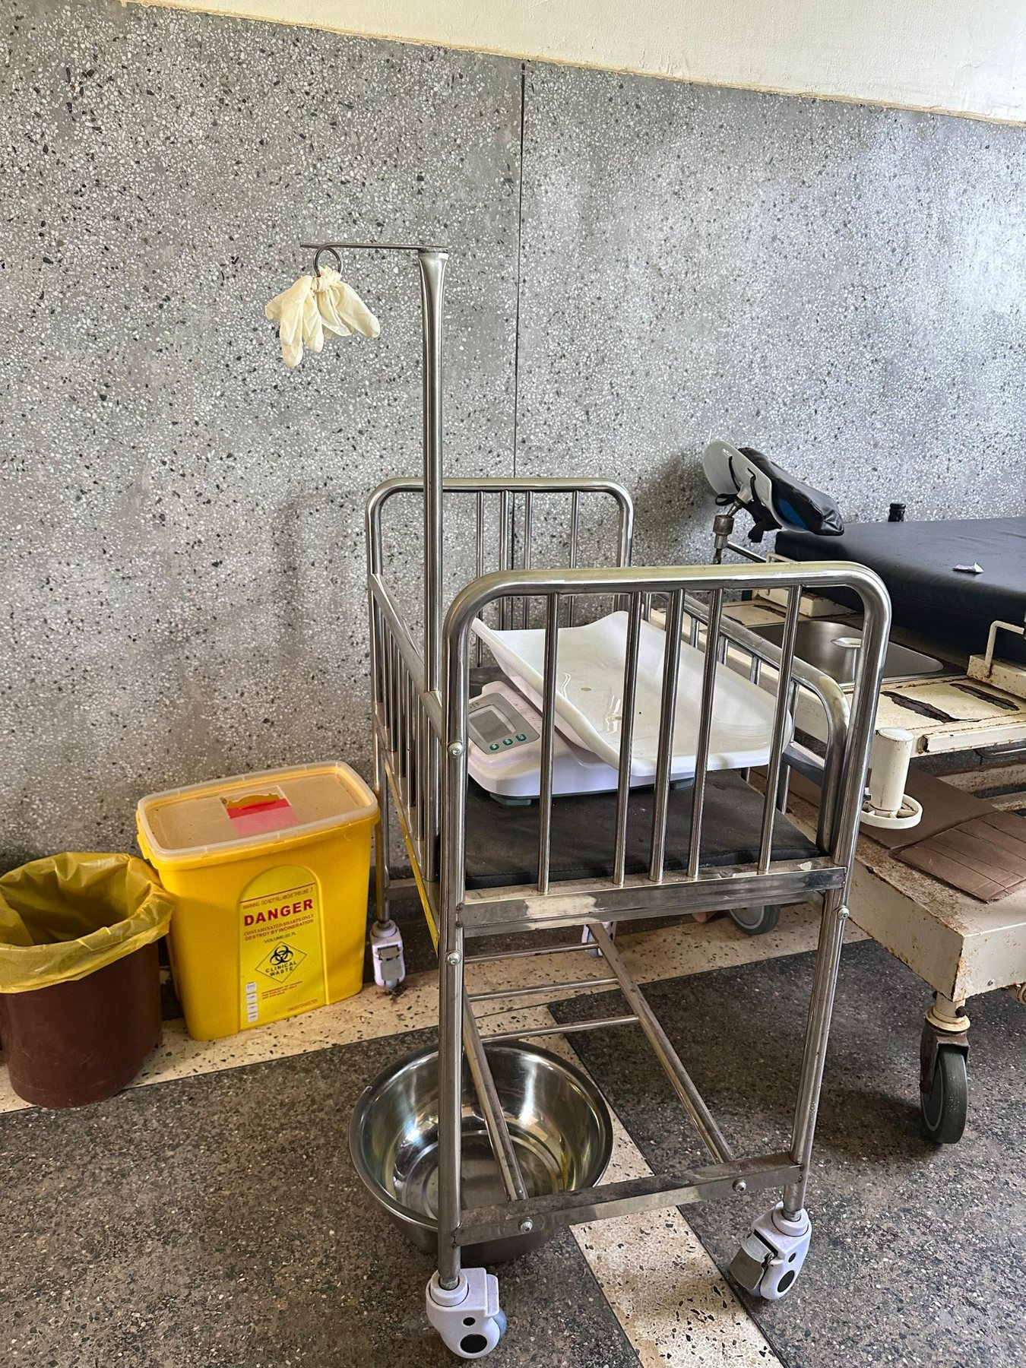
6 | Avogera Health Facility | 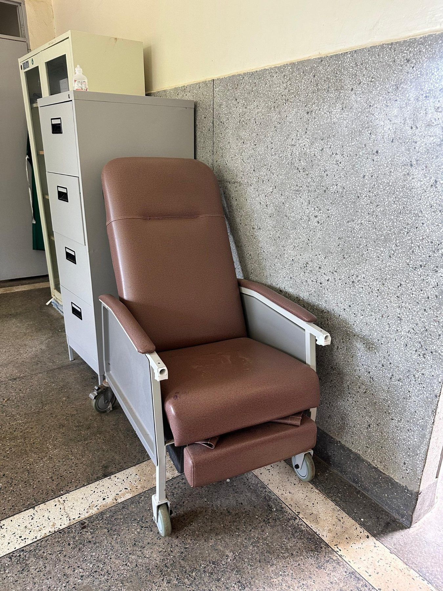
7 | Avogera Health Facility | 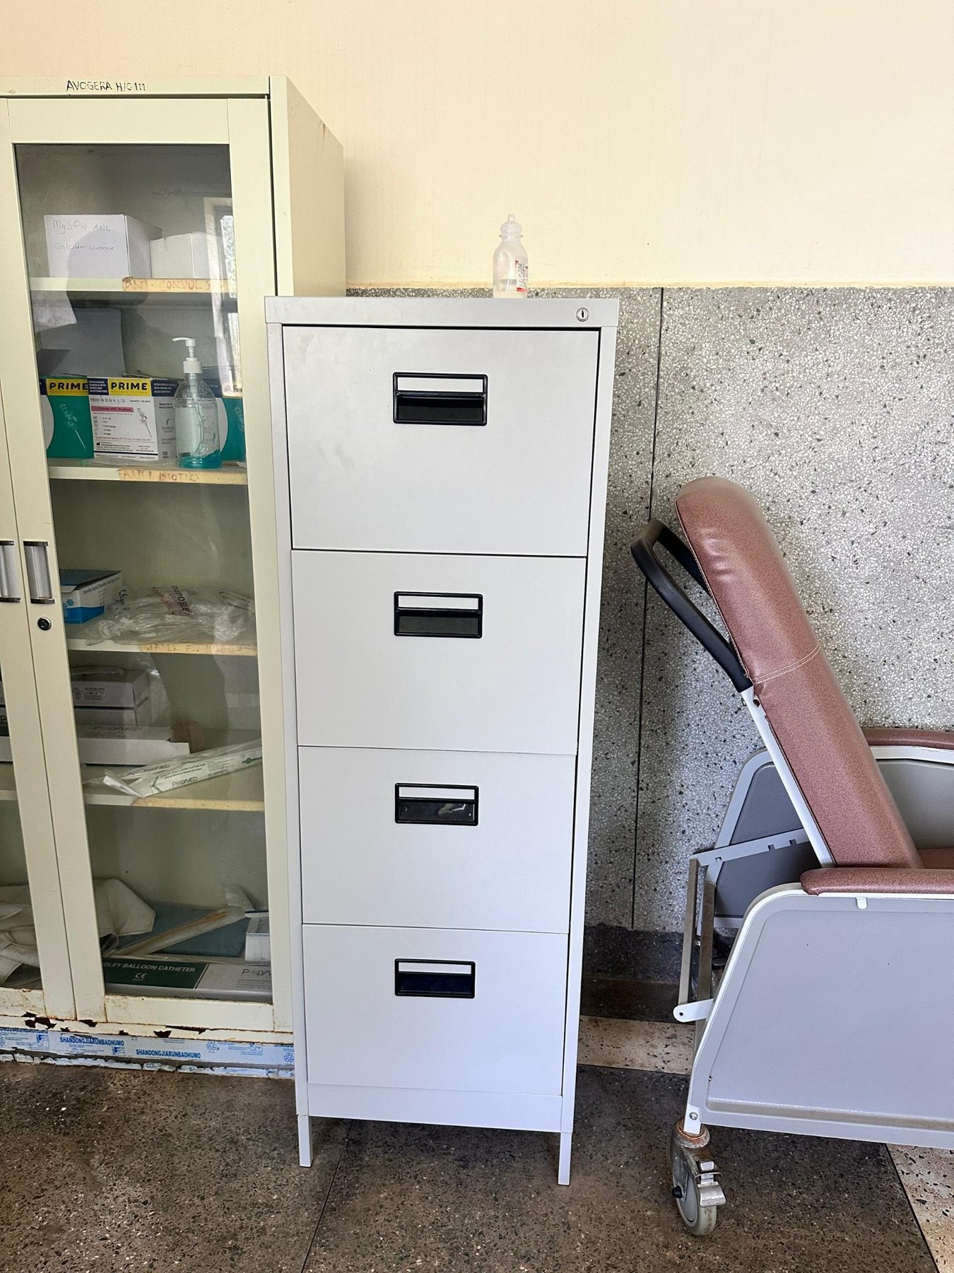
8 | Avogera Health Facility | 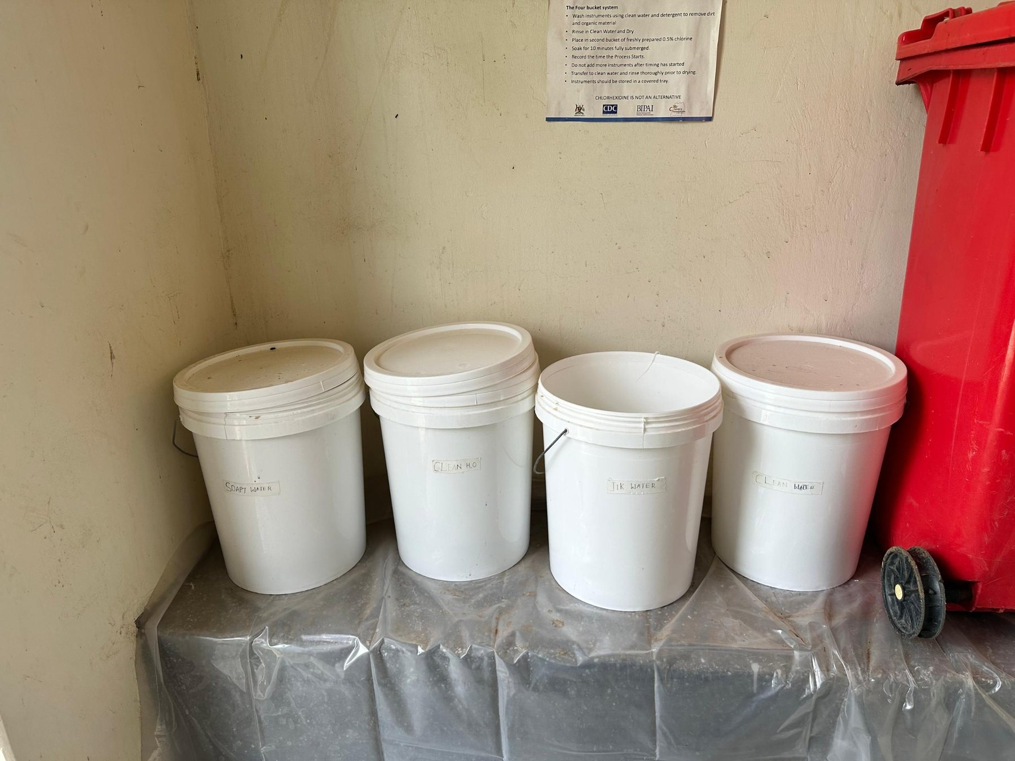
9 | Avogera Health Facility | 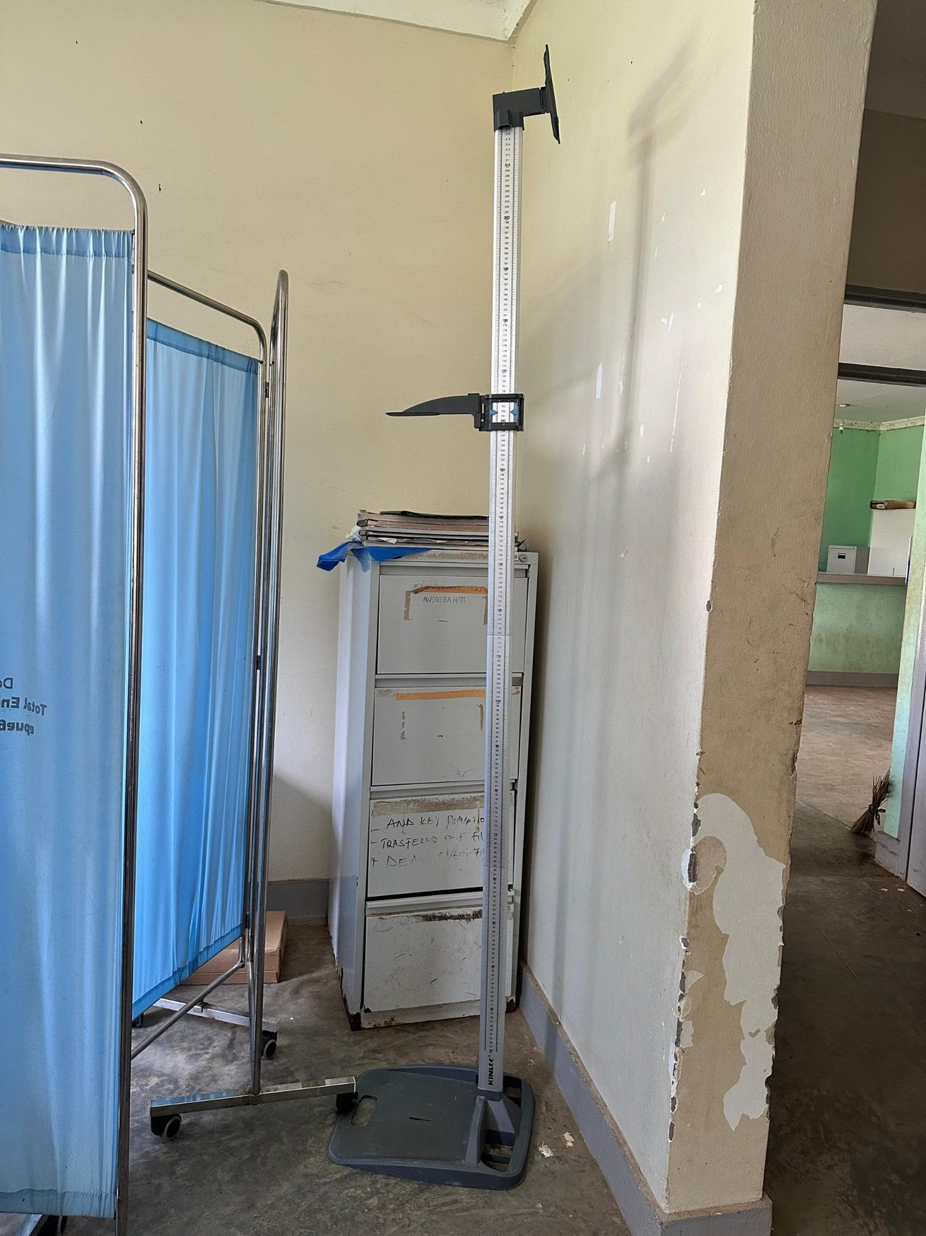
10 | Avogera Health Facility | 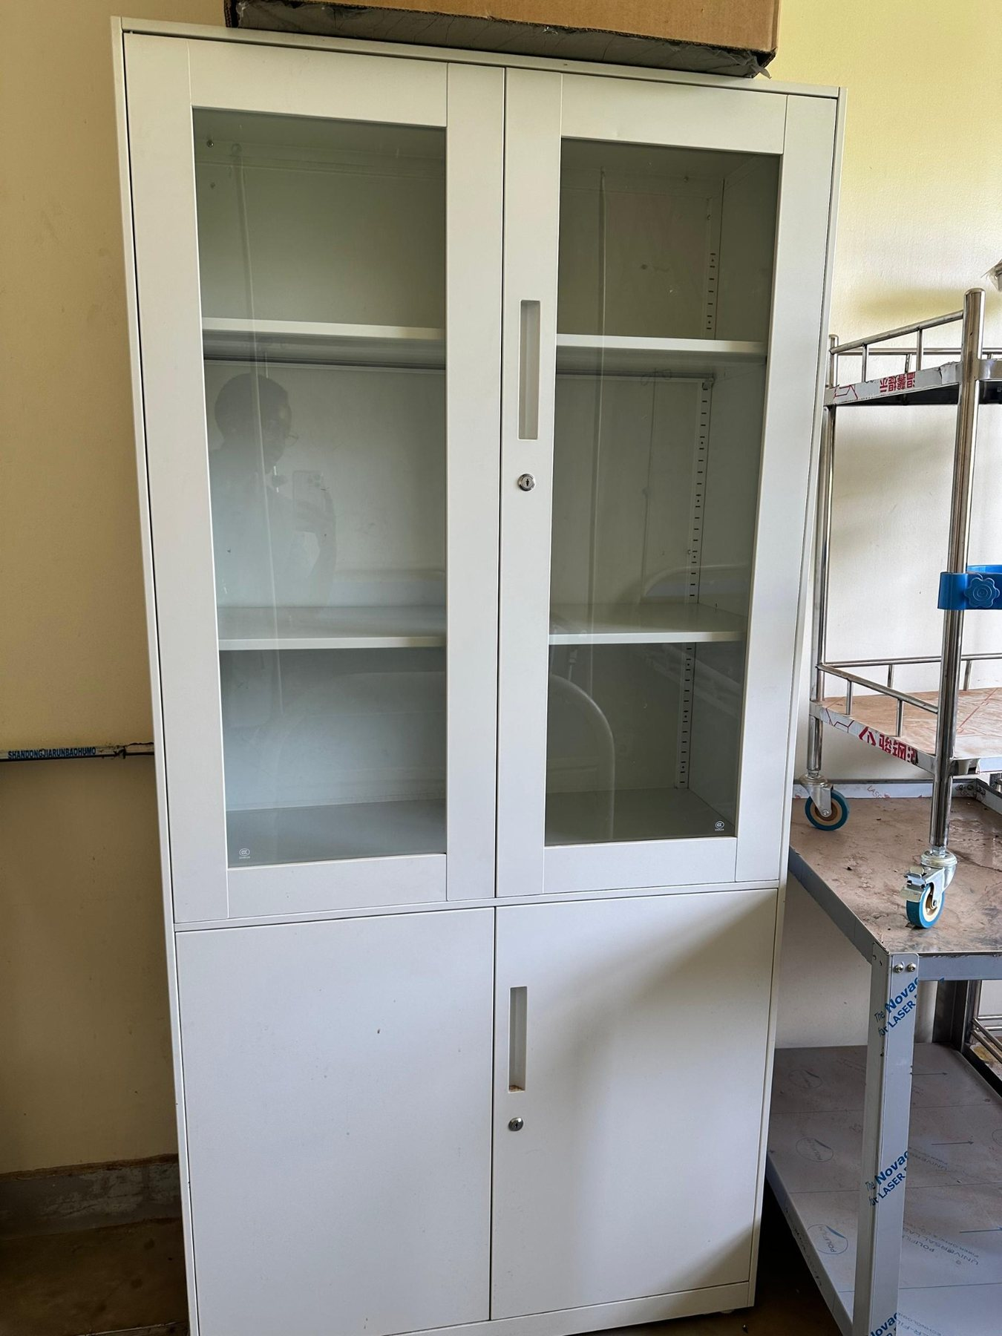
11 | Avogera Health Facility | 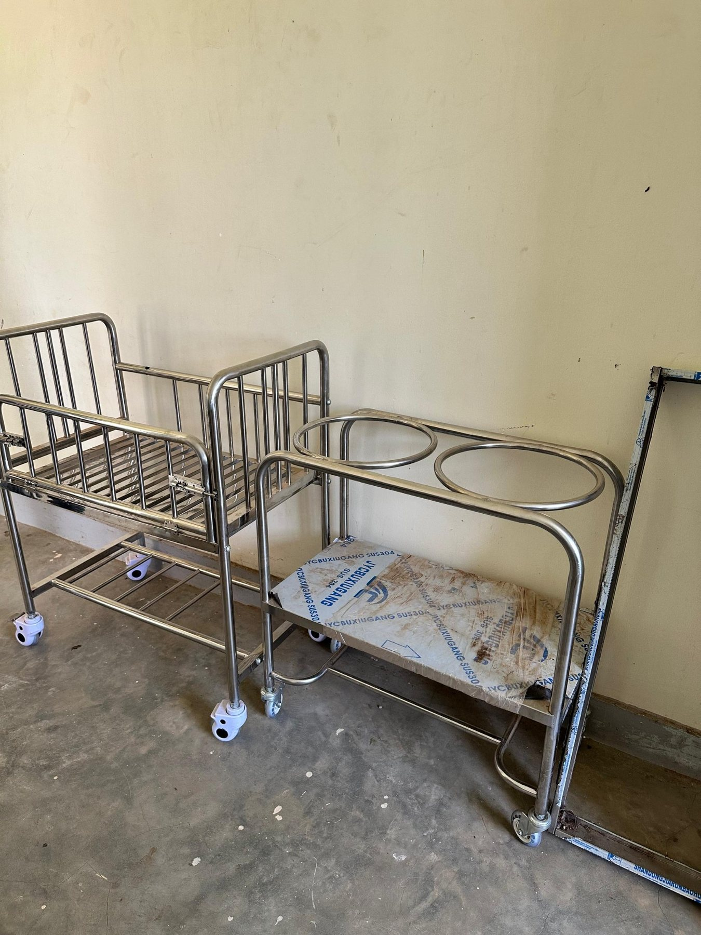
12 | Avogera Health Facility | 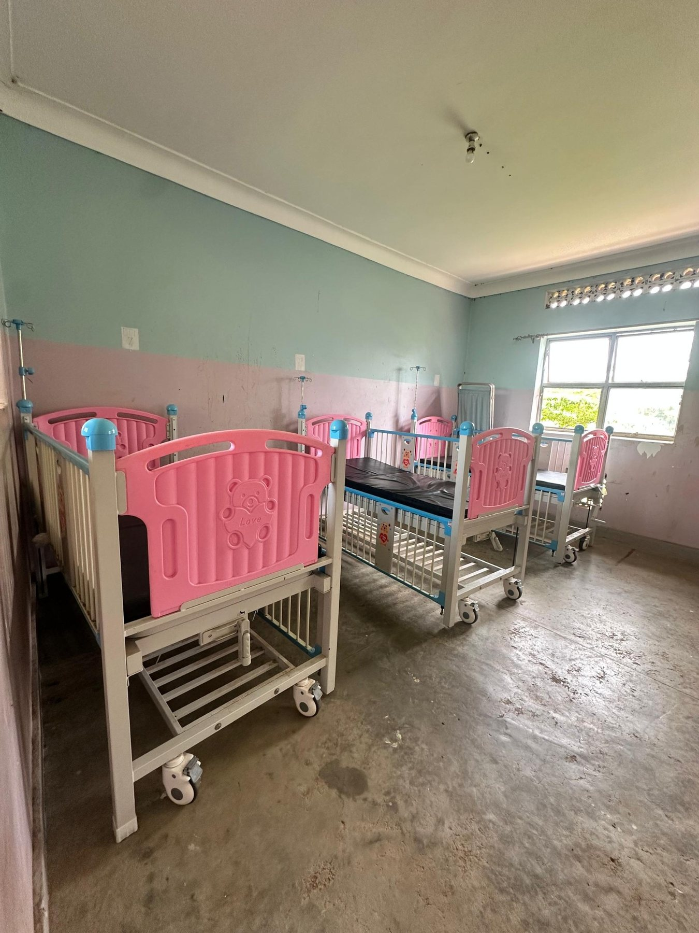
13 | Avogera Health Facility | 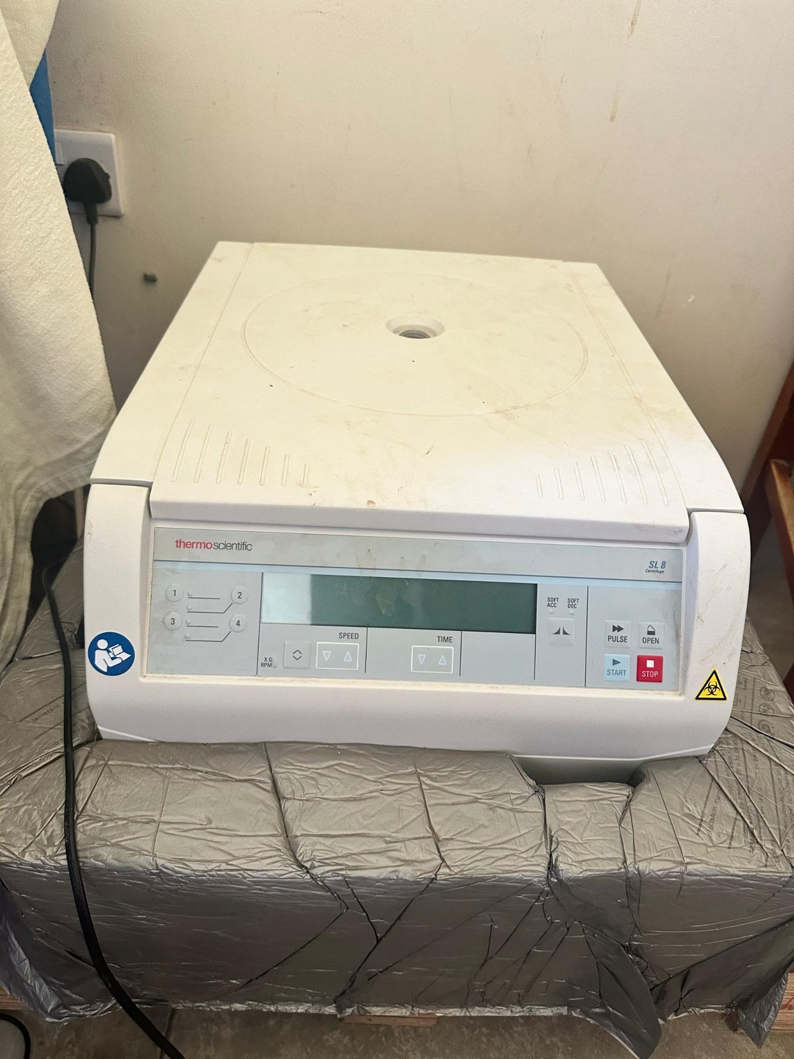
14 | Avogera Health Facility | 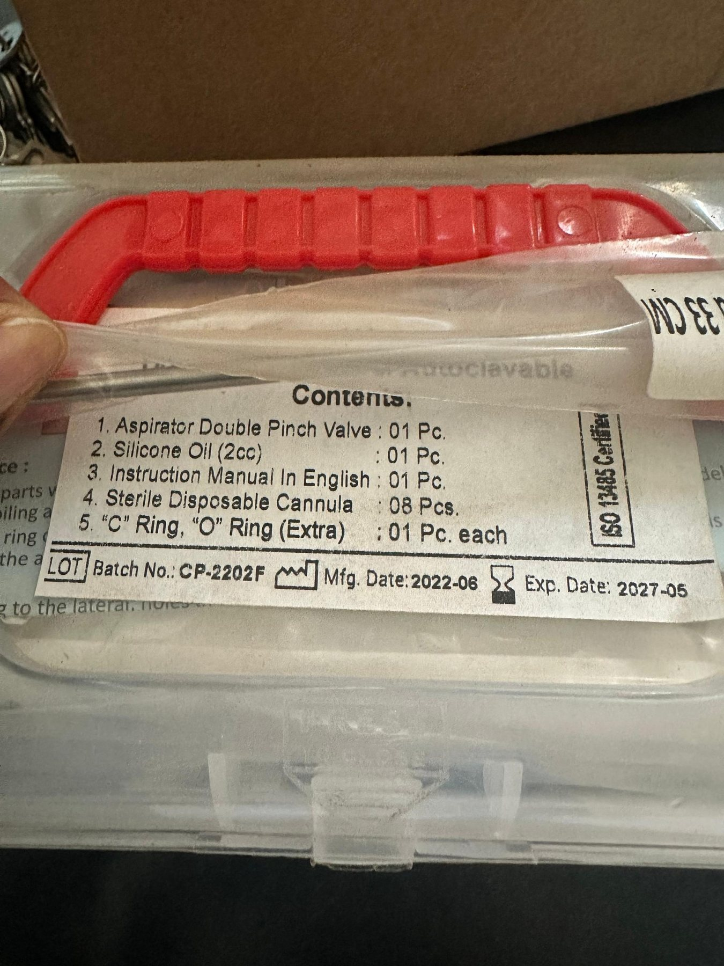
15 | Avogera Health Facility | 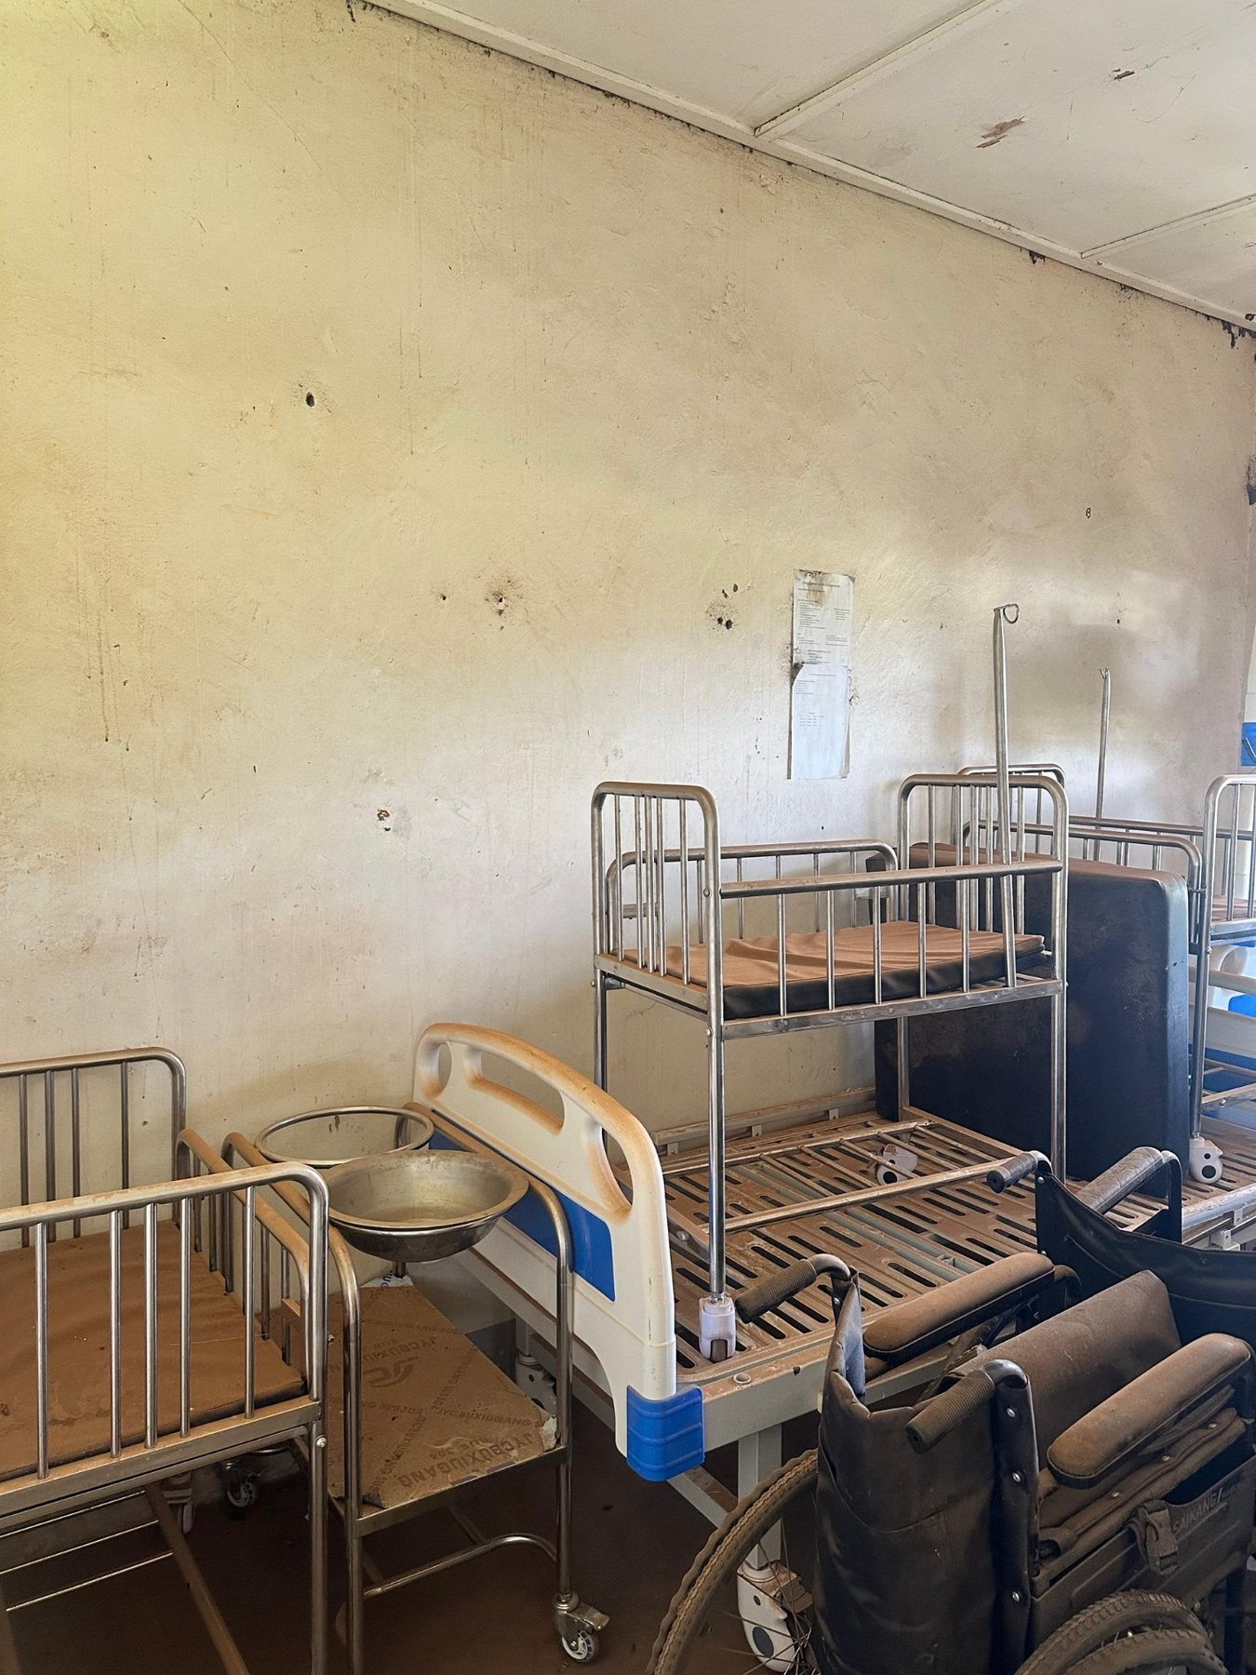
16 | Avogera Health Facility | 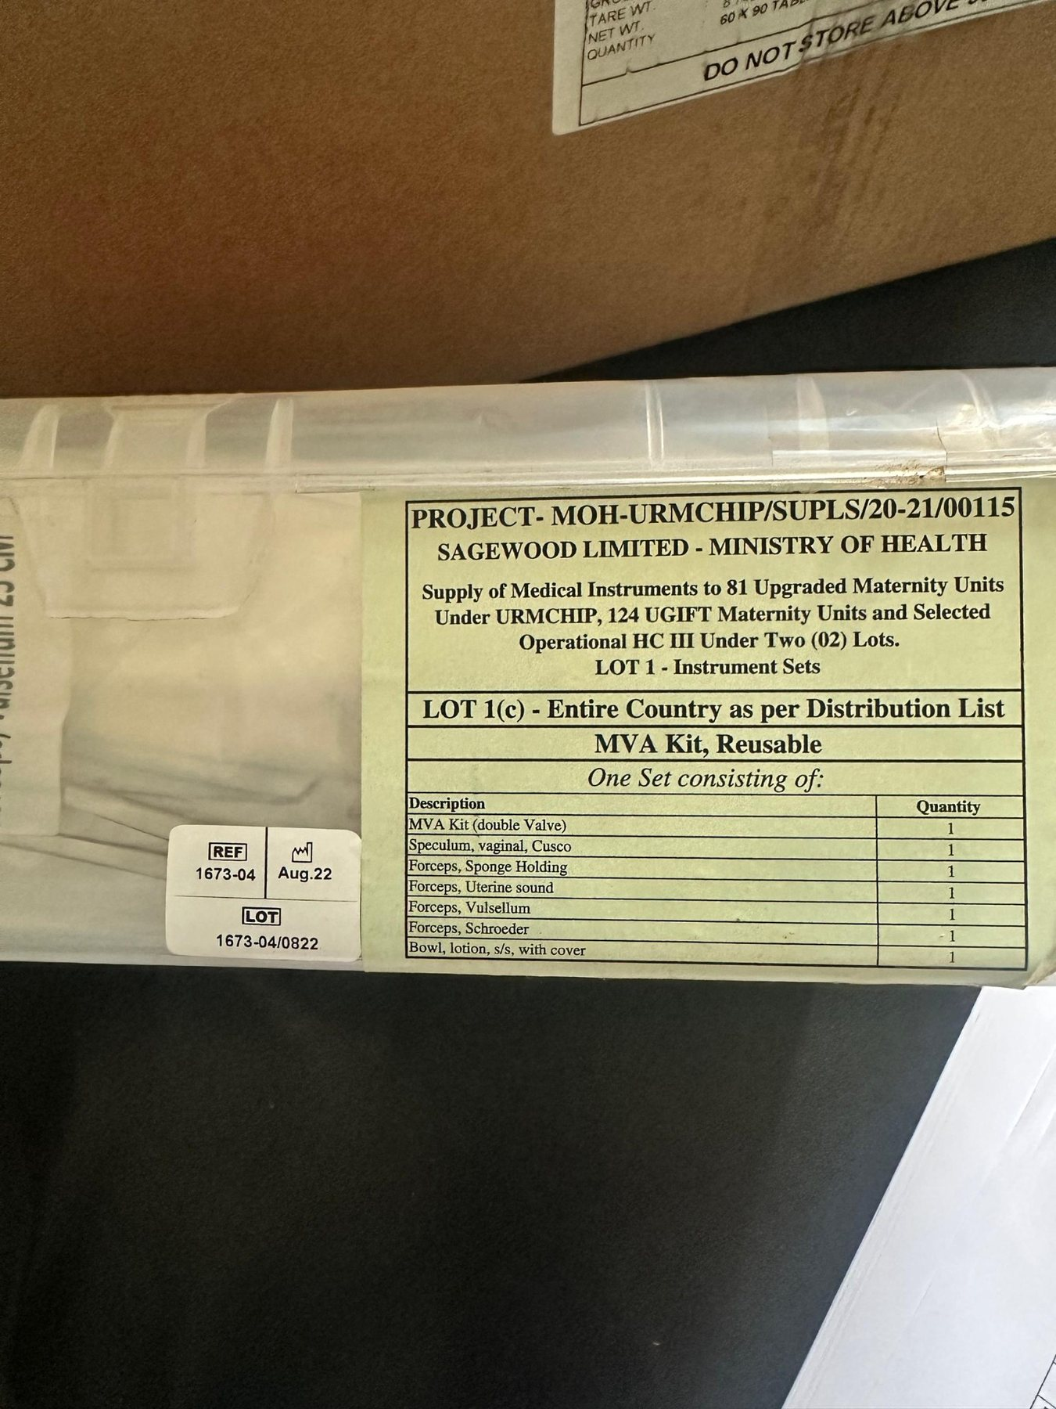
17 | Avogera Health Facility | 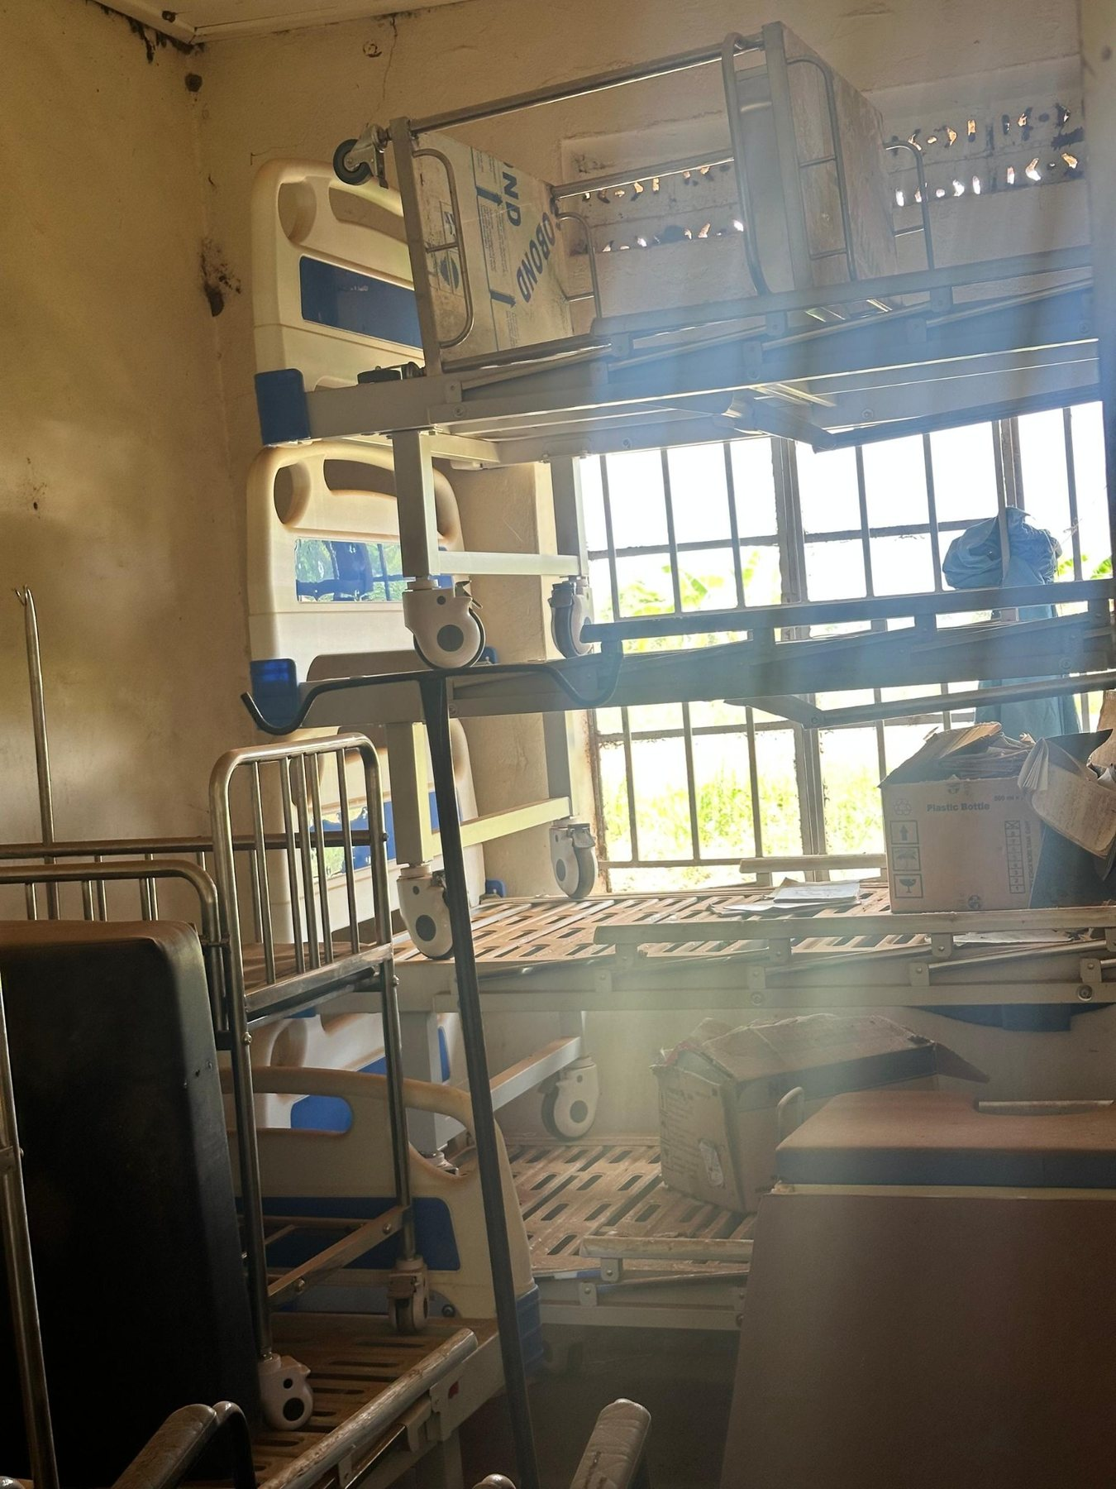
18 | Avogera Health Facility | 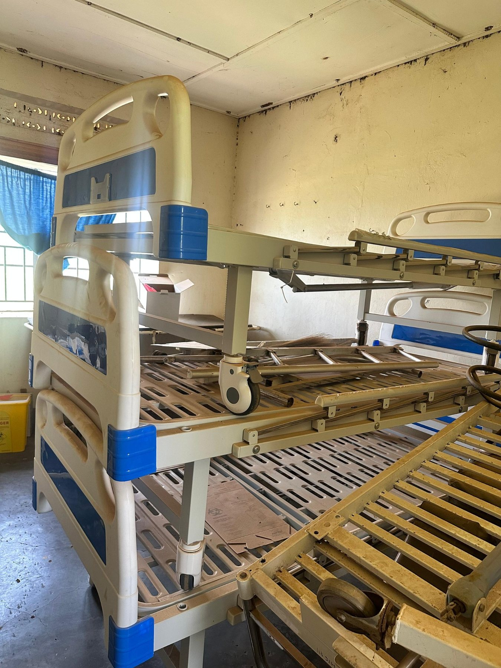
19 | Avogera Health Facility | 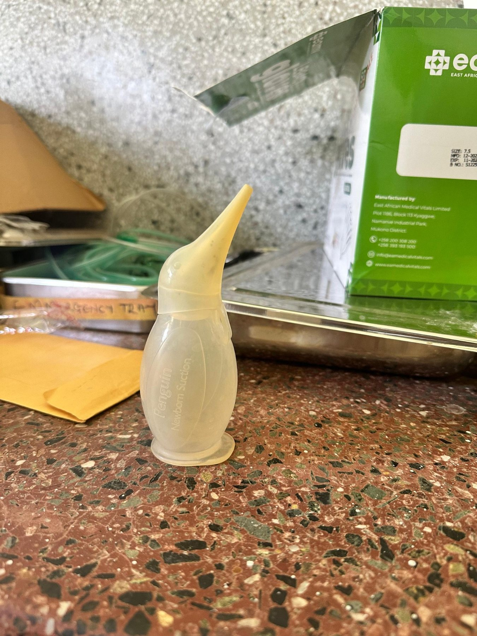
20 | Avogera Health Facility | 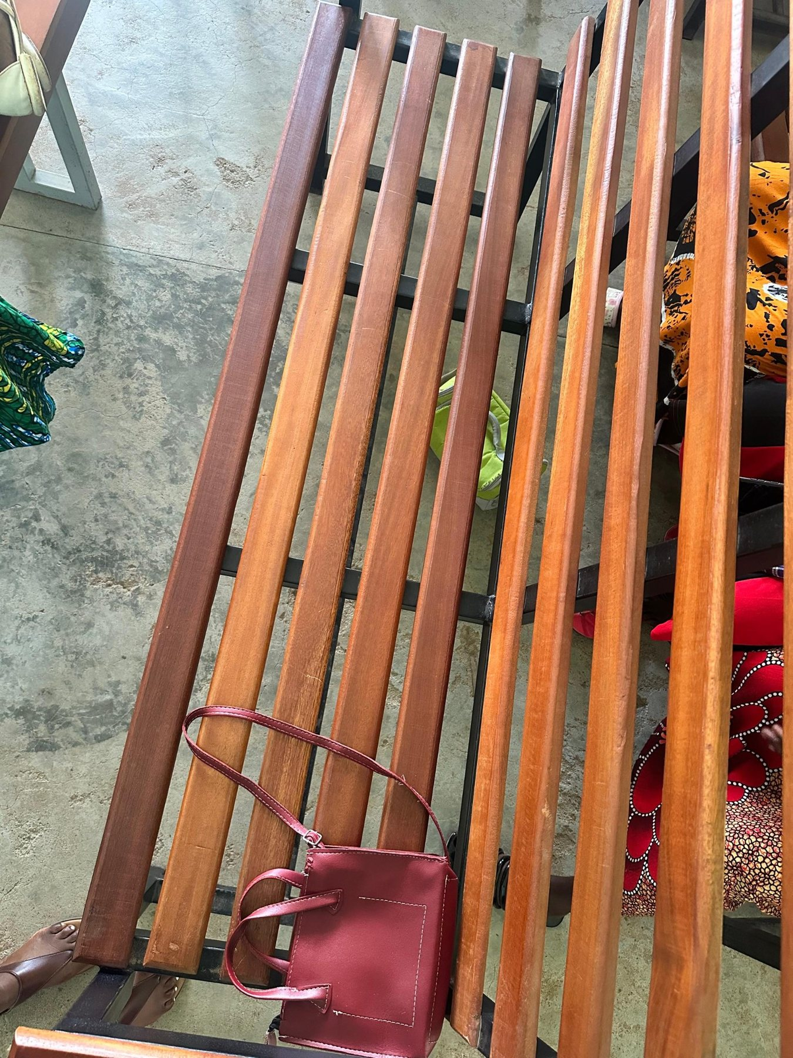
21 | Avogera Health Facility | 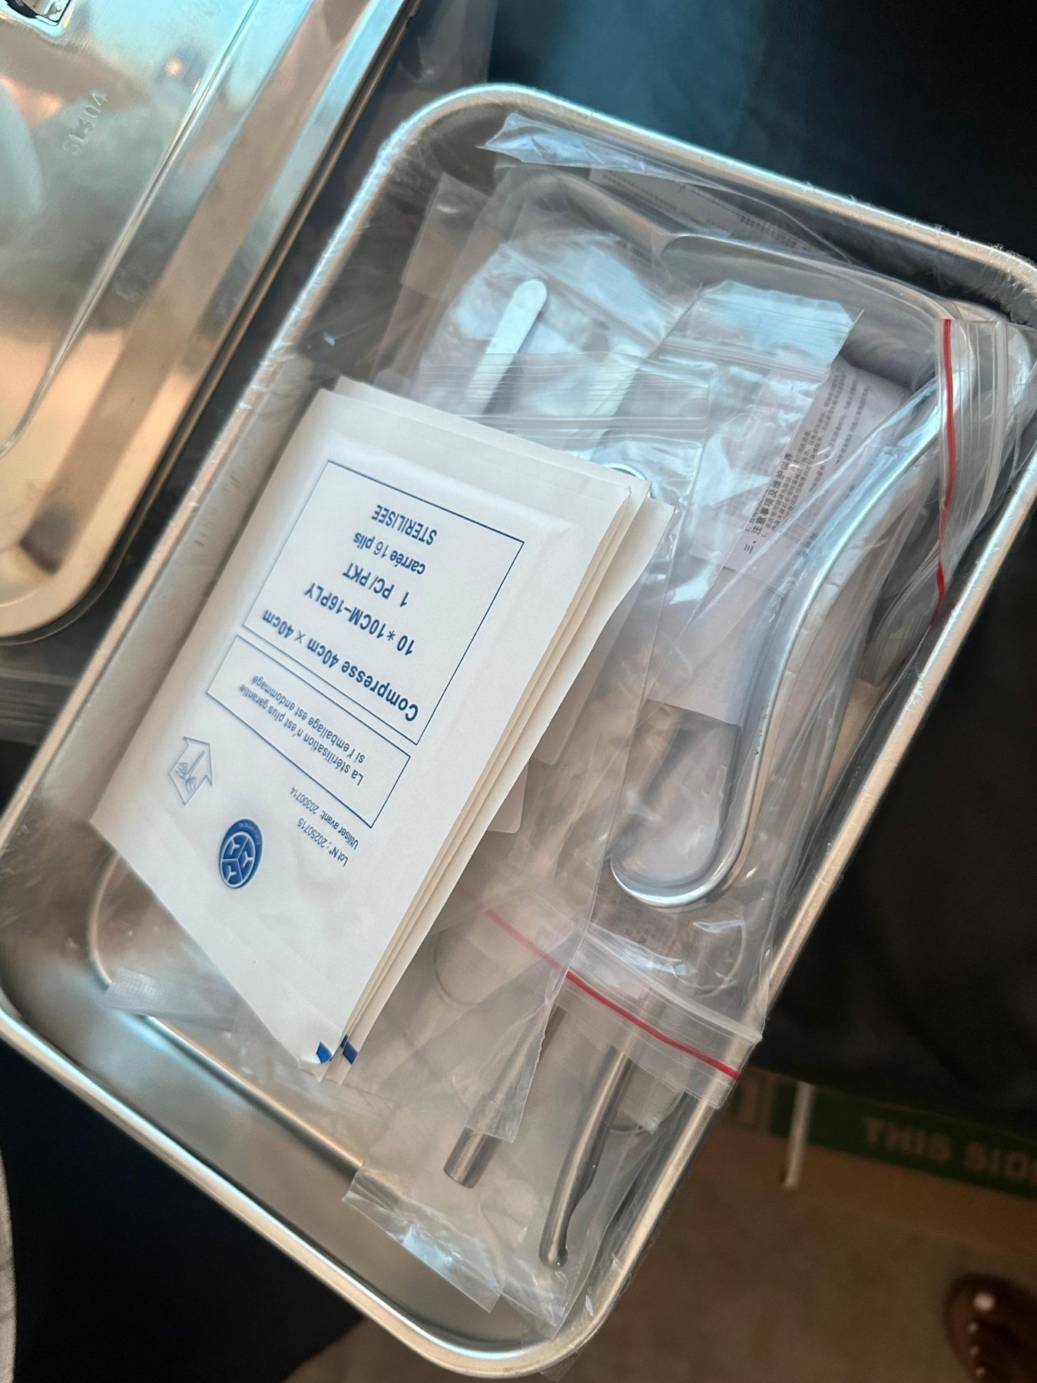
22 | Avogera Health Facility | 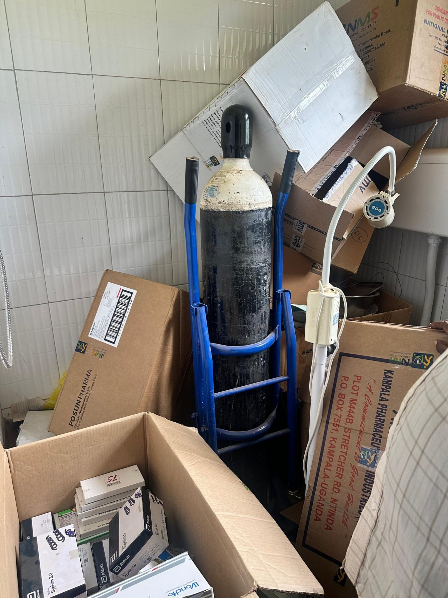
23 | Avogera Health Facility | 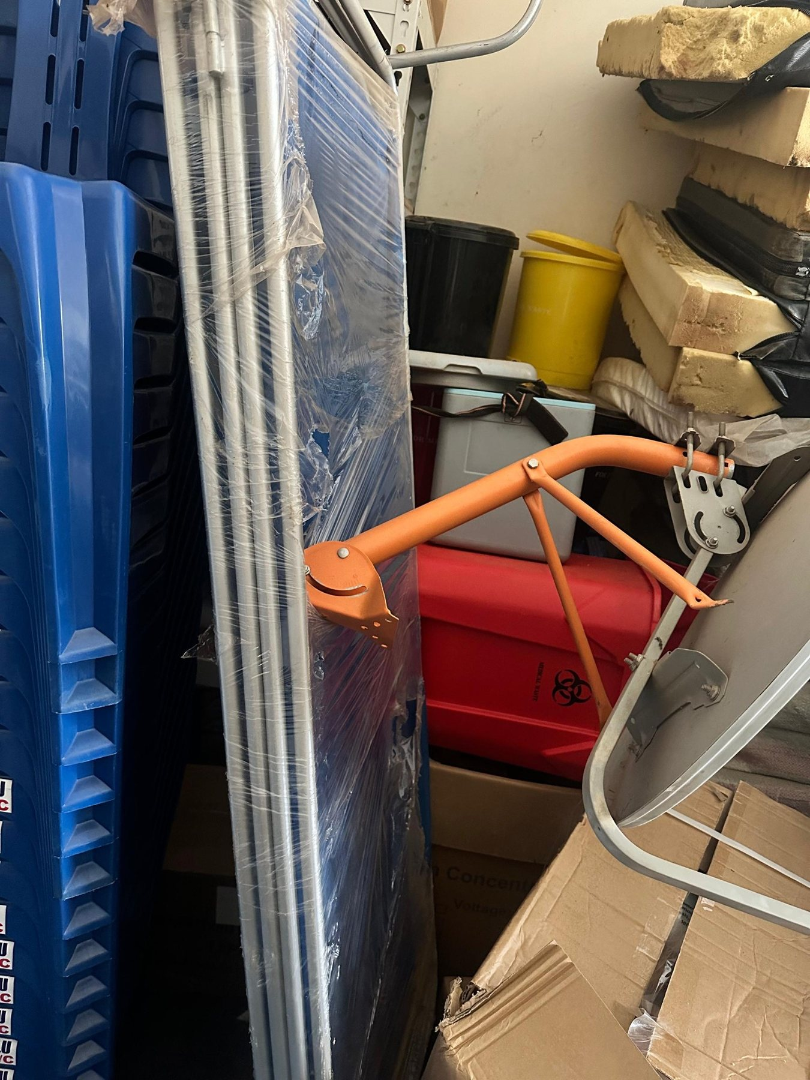
24 | Avogera Health Facility | 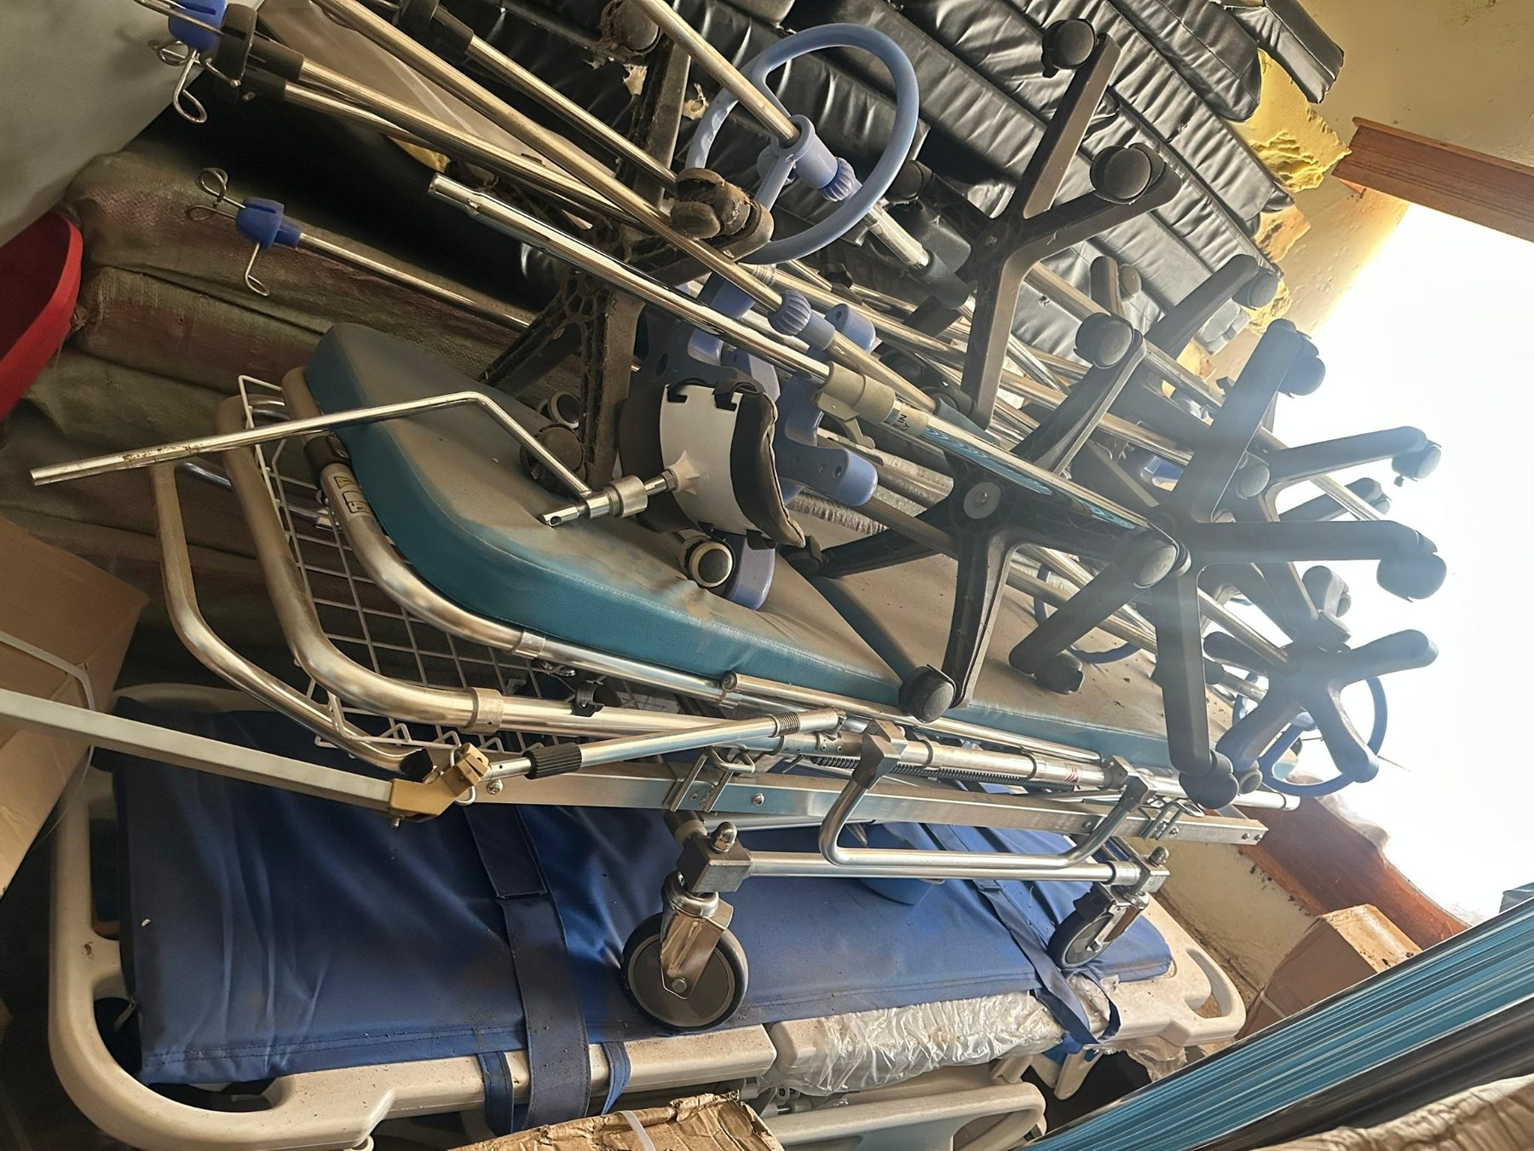
25 | Avogera Health Facility | 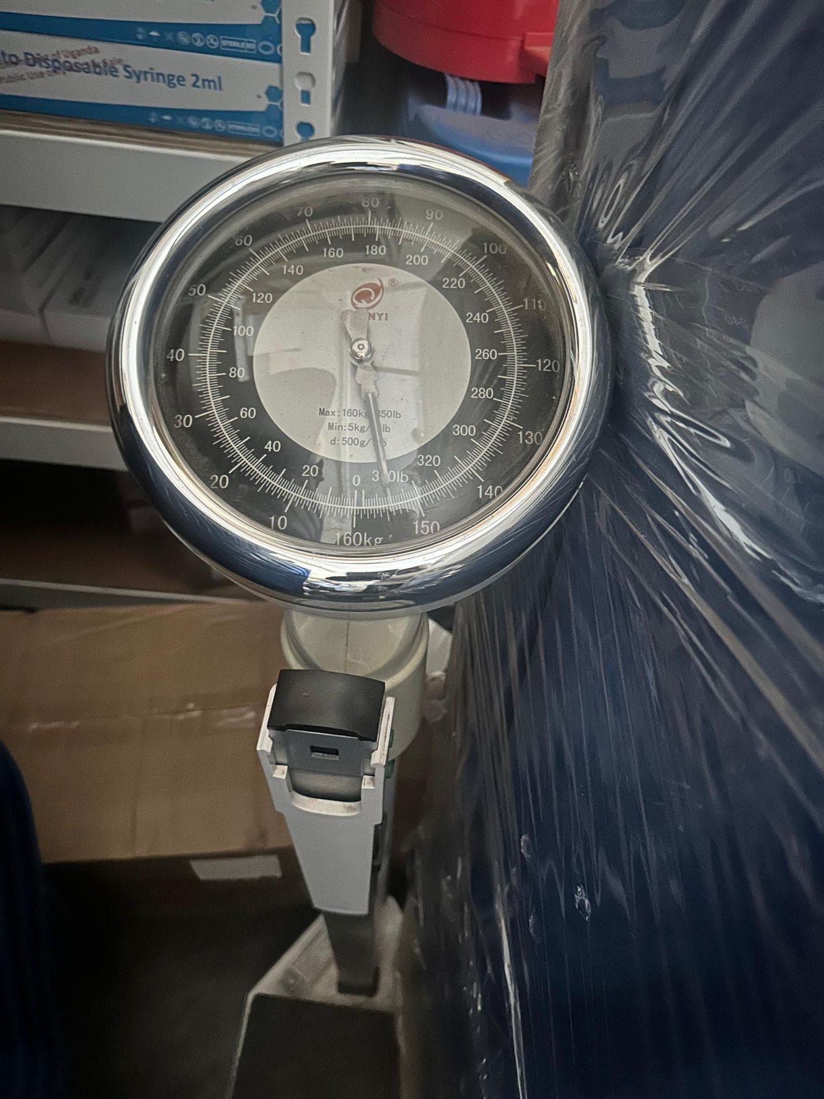
26 | Avogera Health Facility | 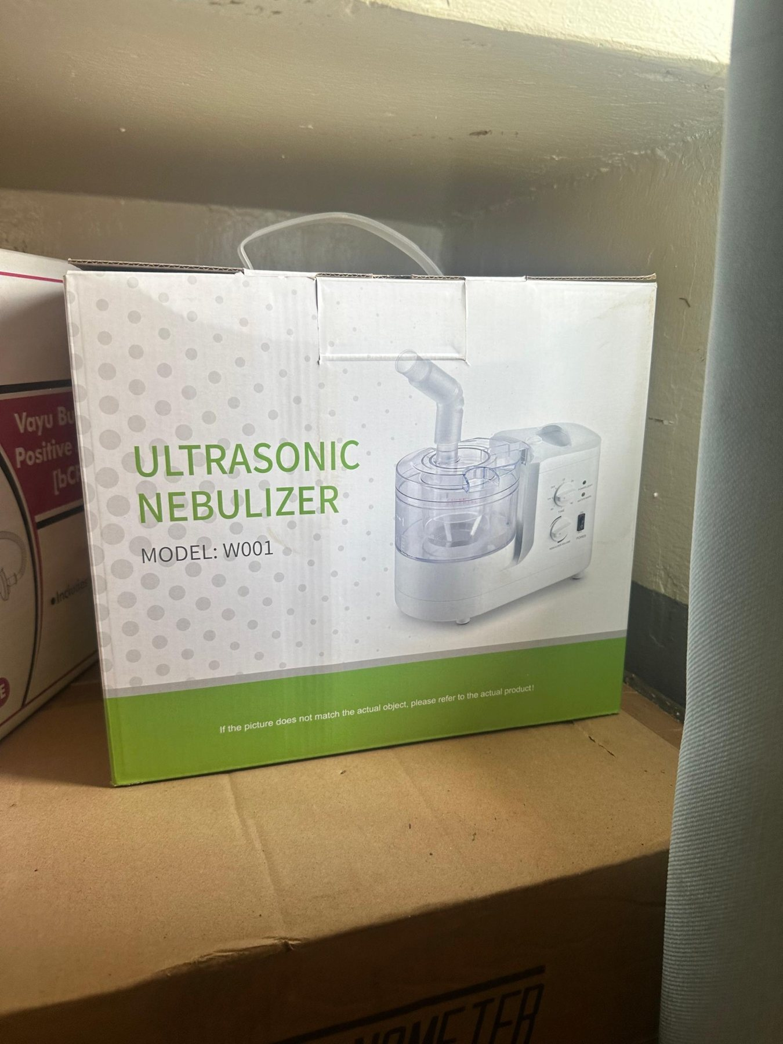
27 | Avogera Health Facility | 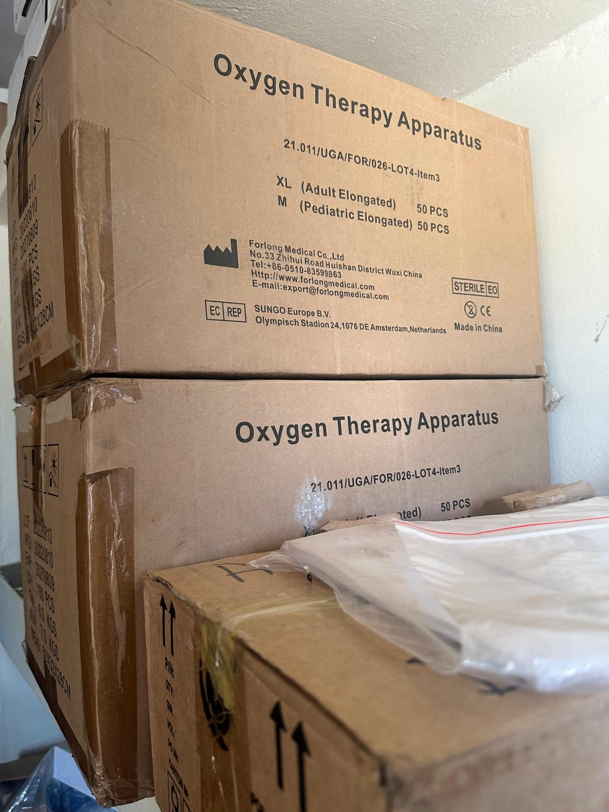
28 | Avogera Health Facility | 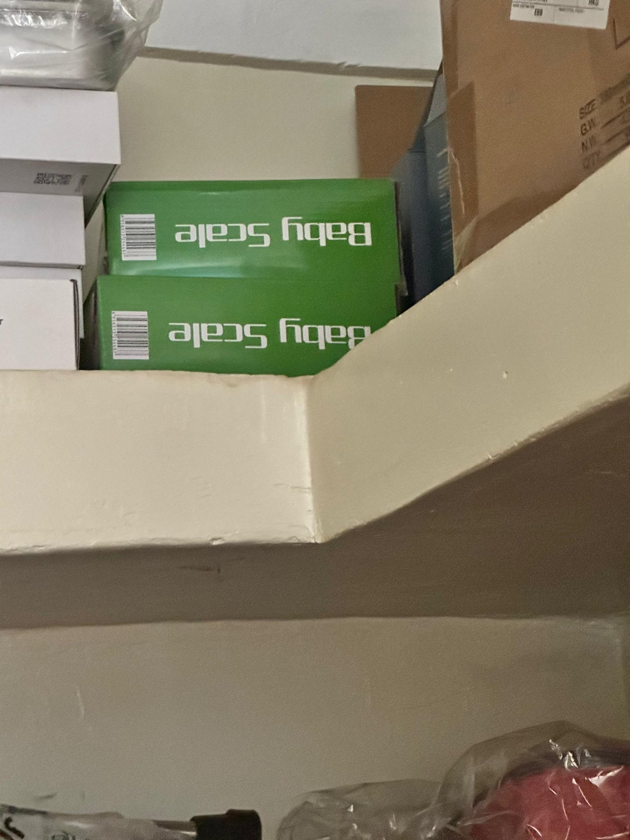
29 | Avogera Health Facility | 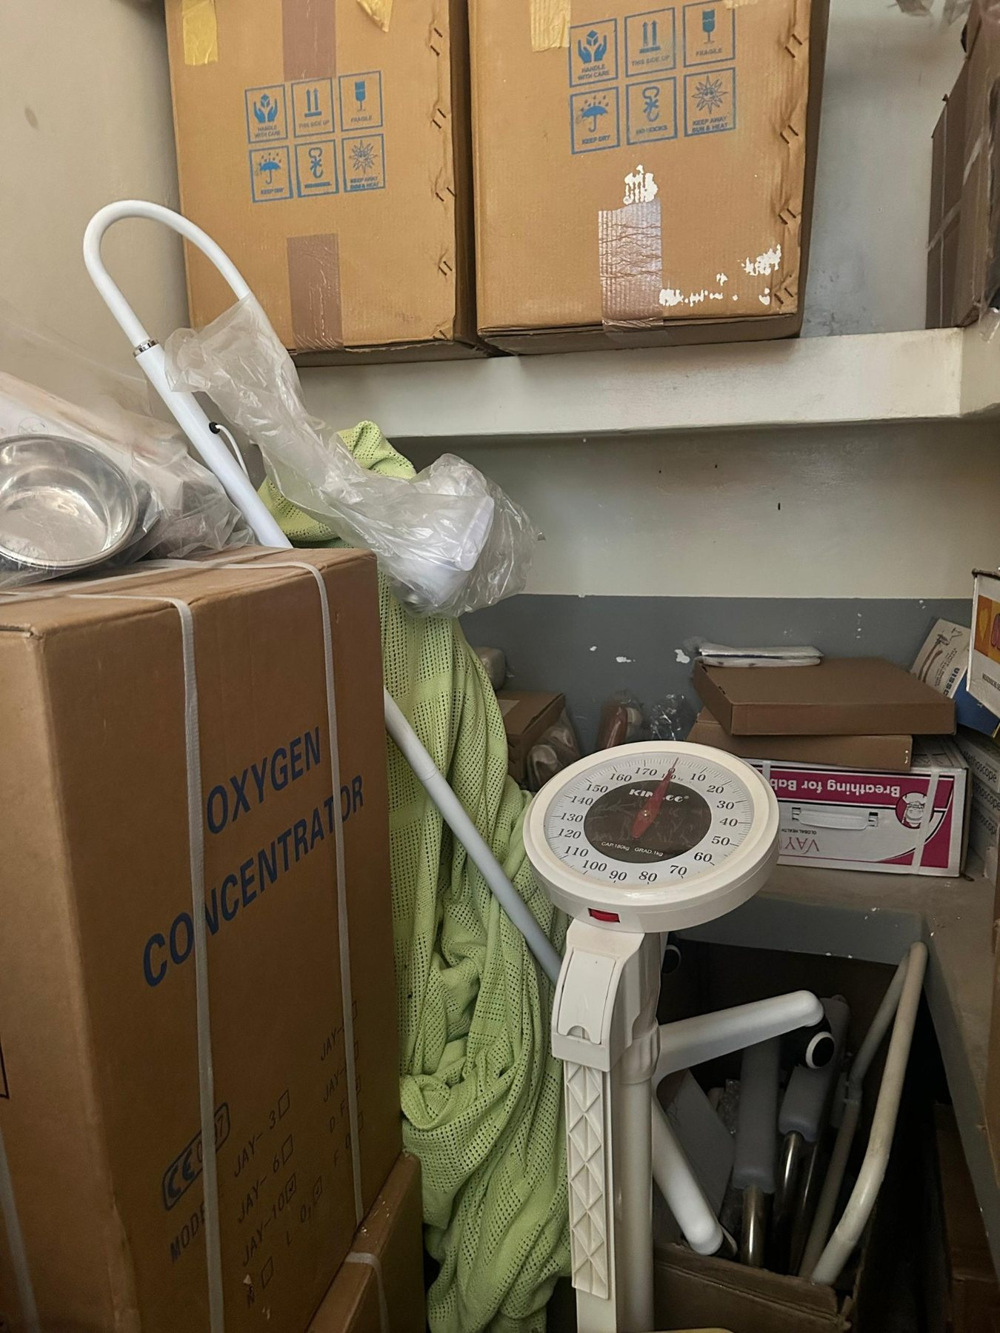
30 | Avogera Health Facility | 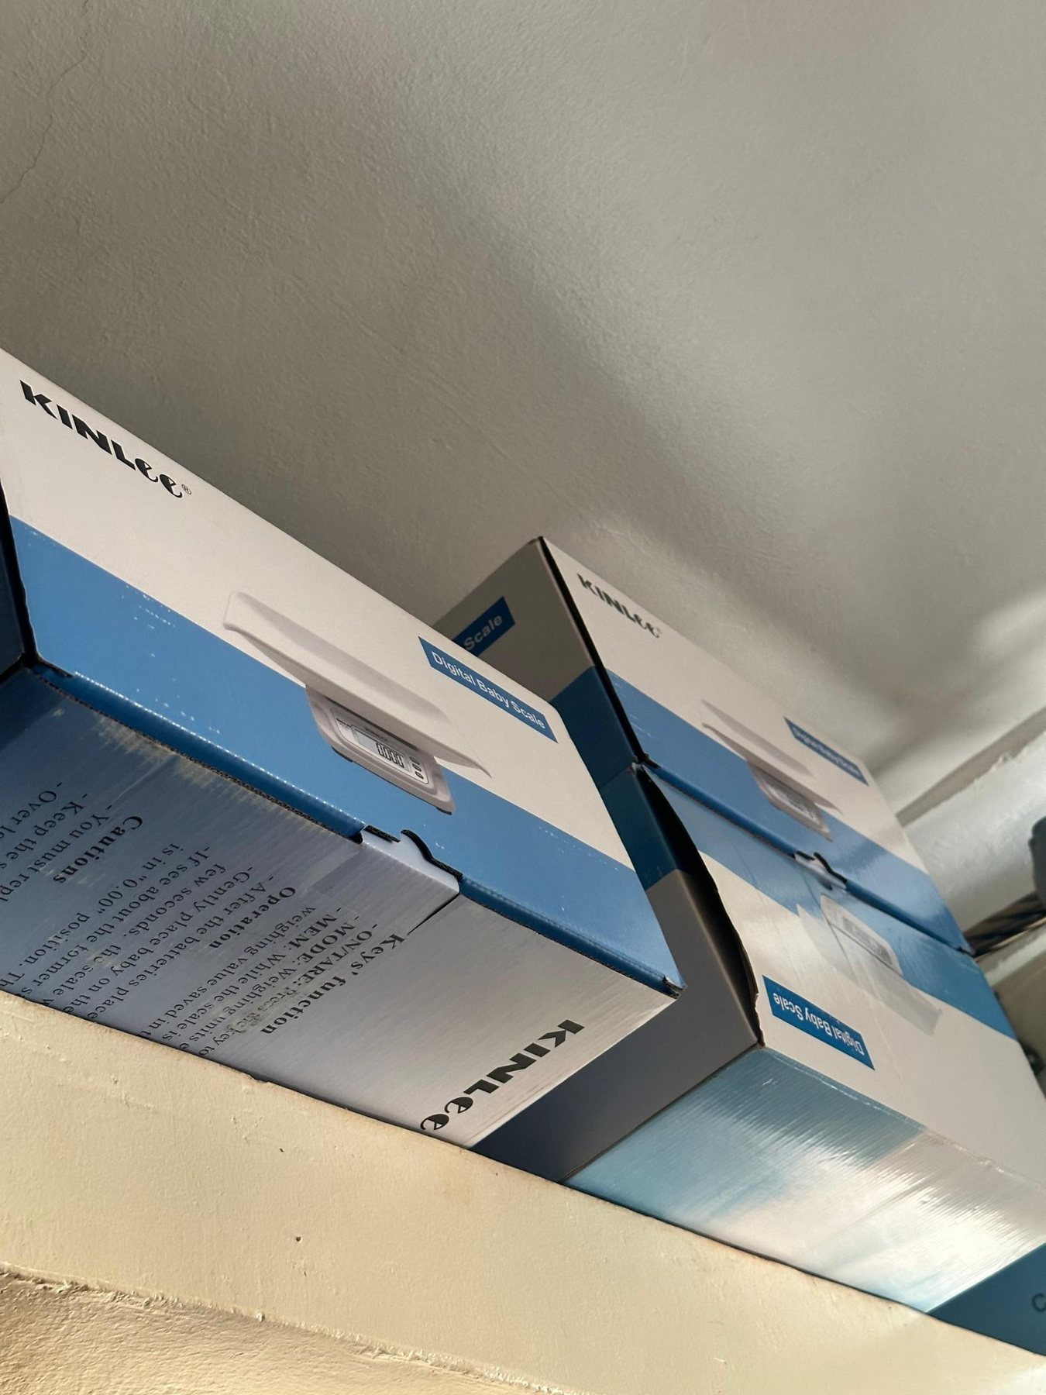
31 | Avogera Health Facility | 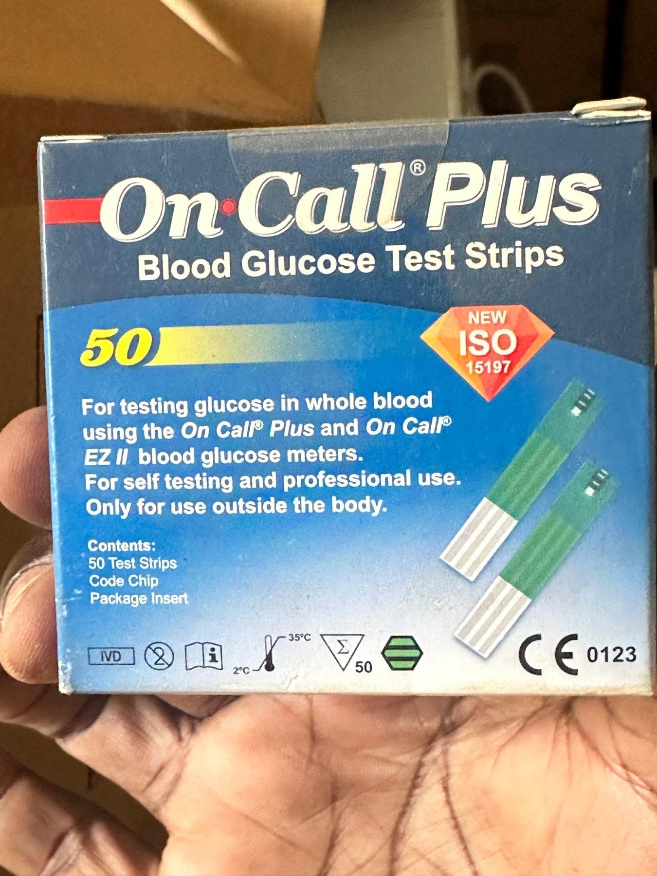
32 | Avogera Health Facility | 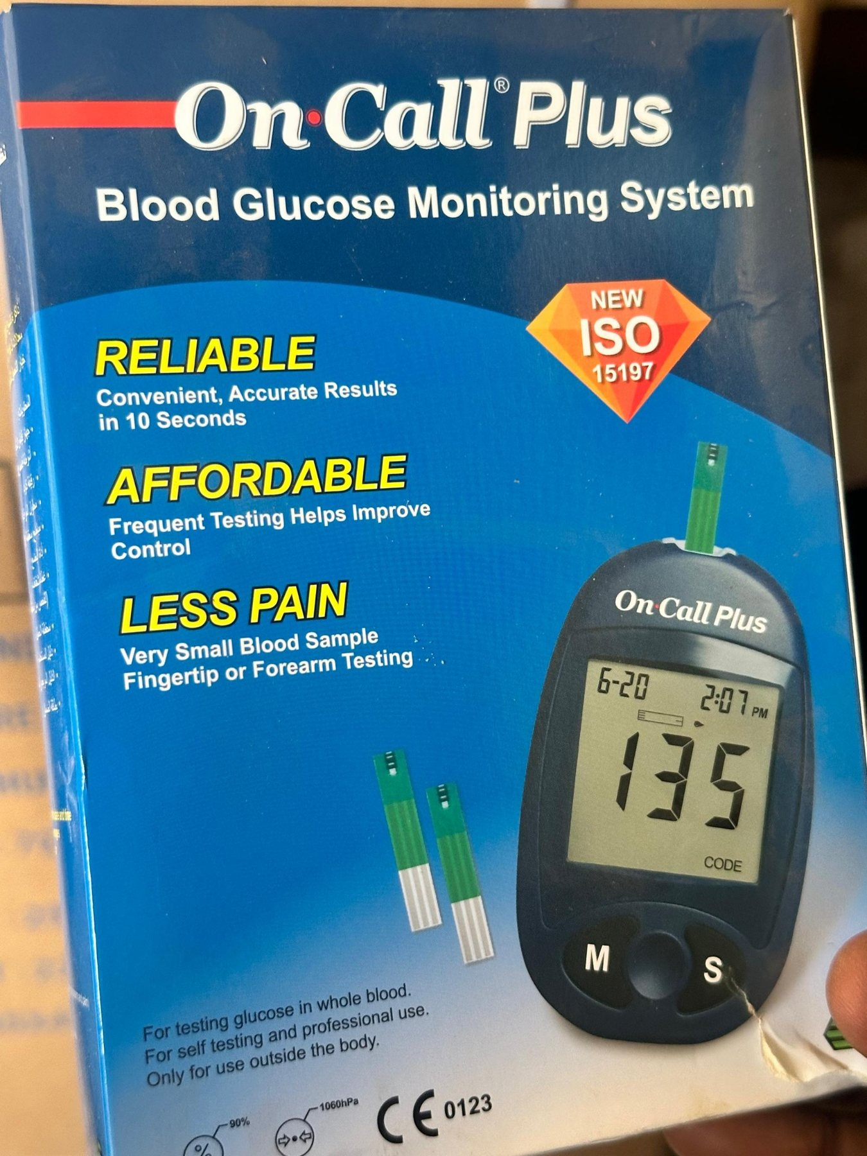
33 | Avogera Health Facility | 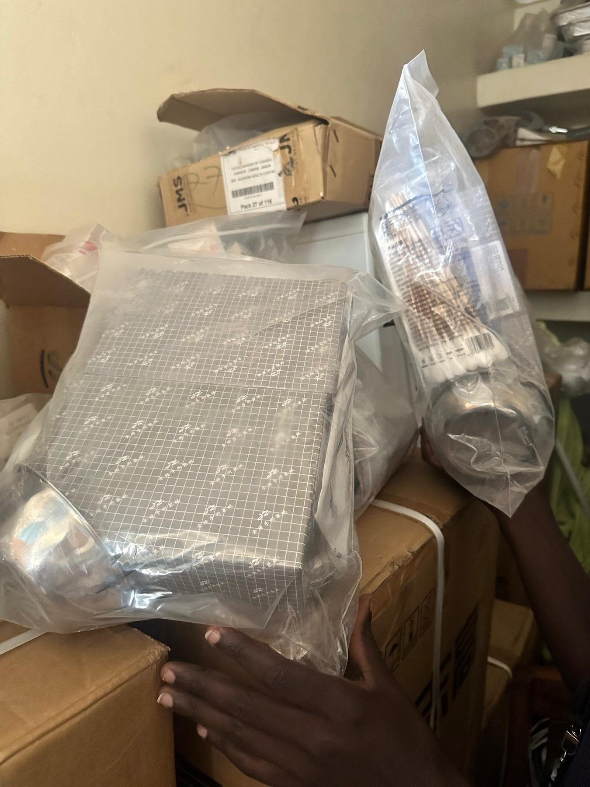
34 | Avogera Health Facility | 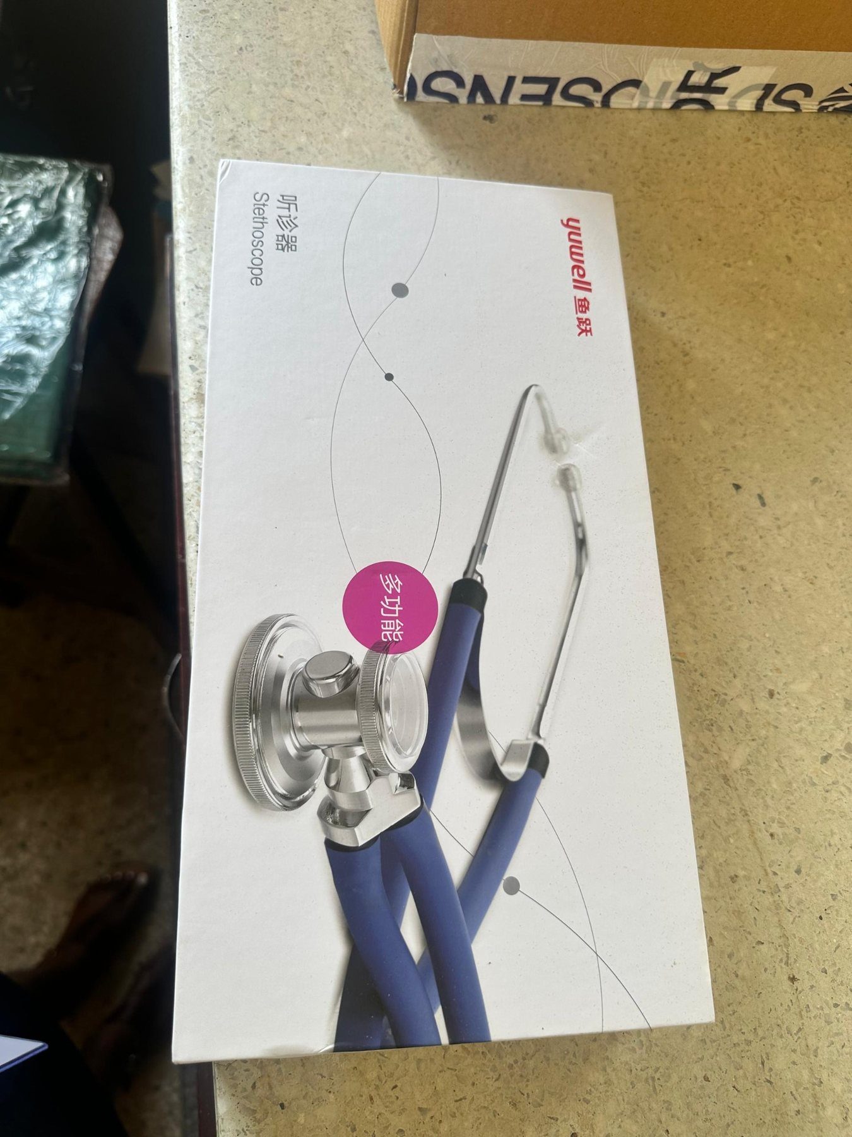
35 | Avogera Health Facility | 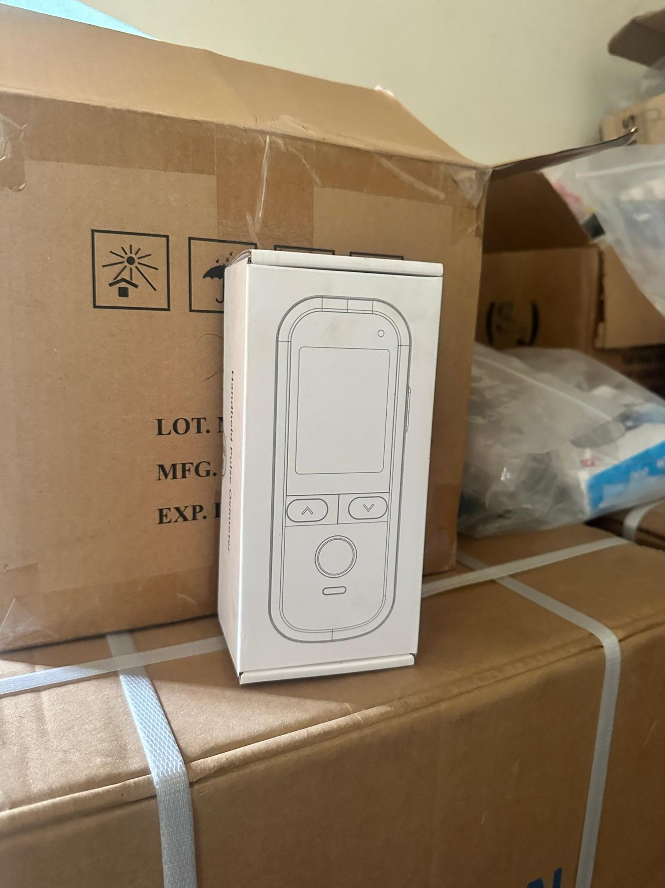
36 | Avogera Health Facility | 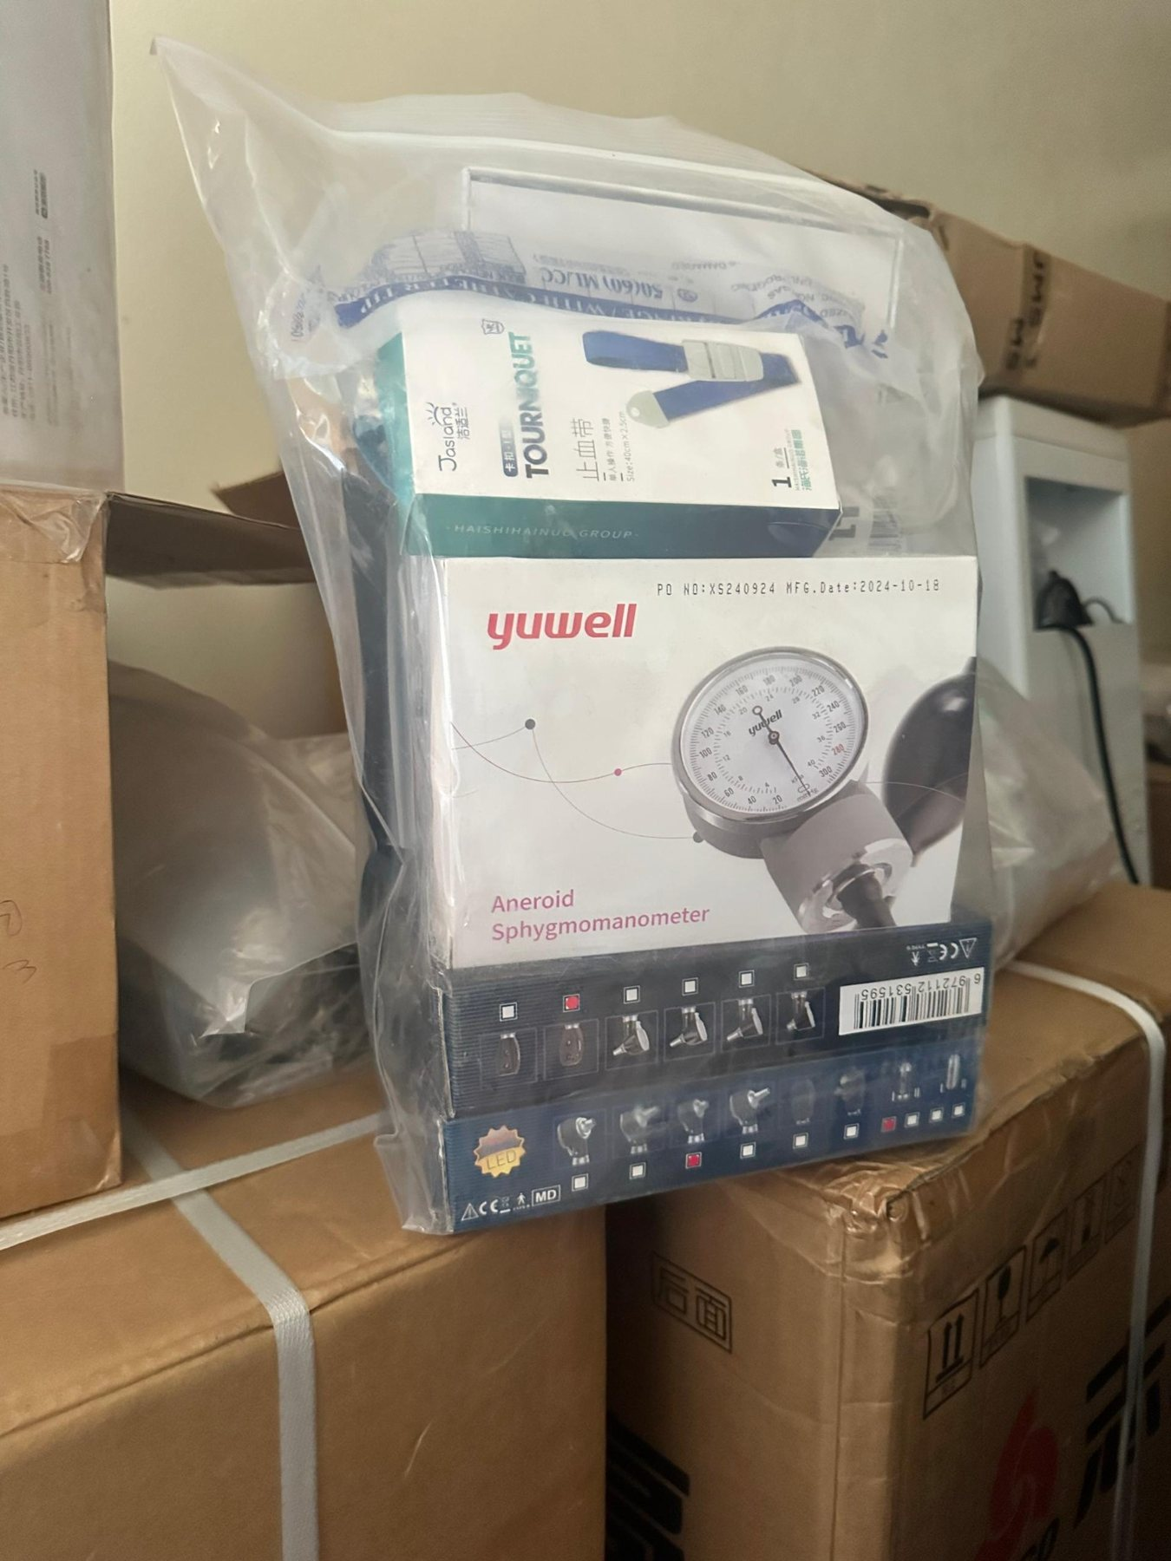
37 | Avogera Health Facility | 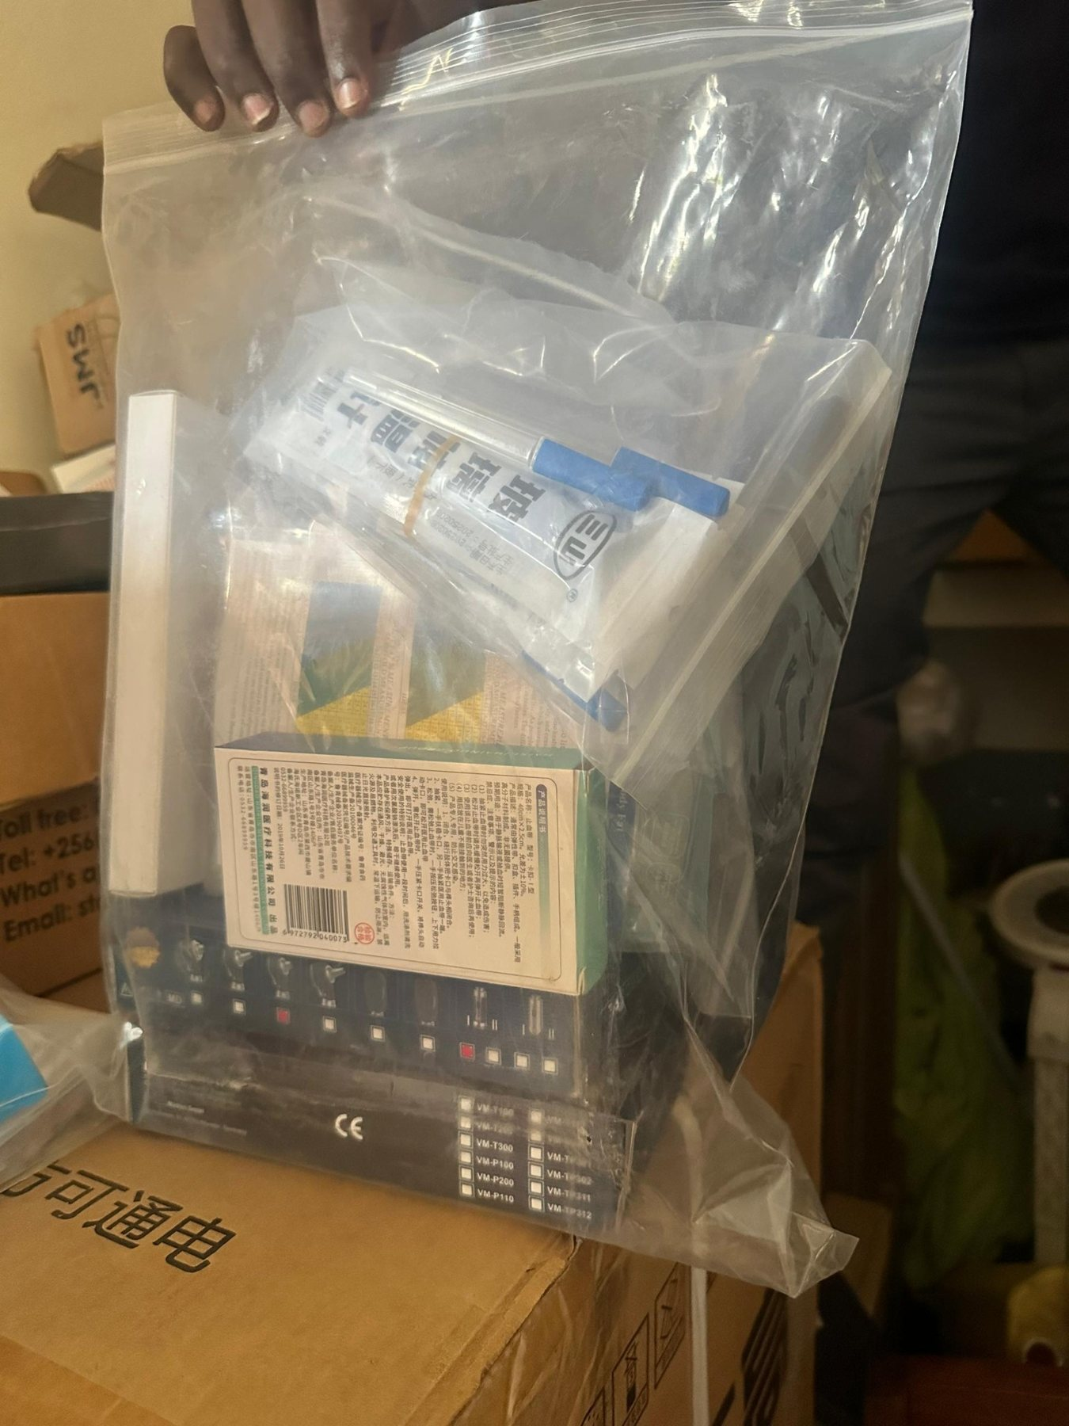
38 | Avogera Health Facility | 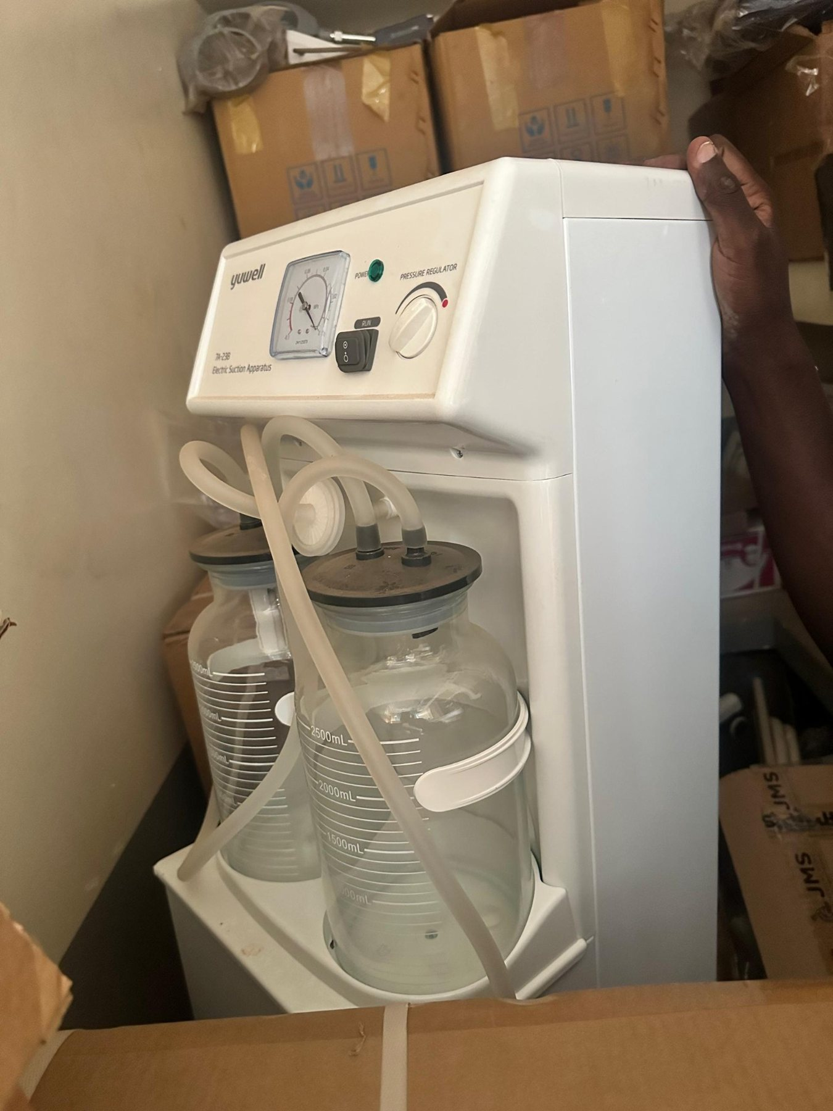
39 | Avogera Health Facility | 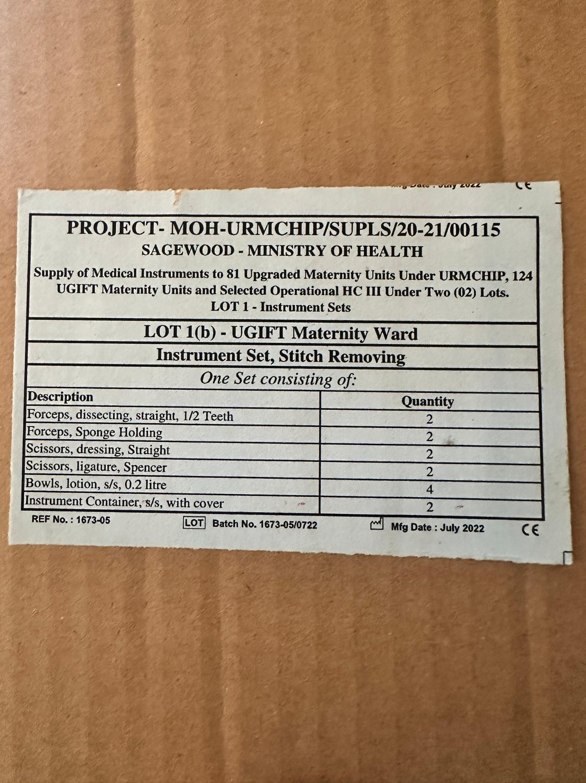
40 | Avogera Health Facility | 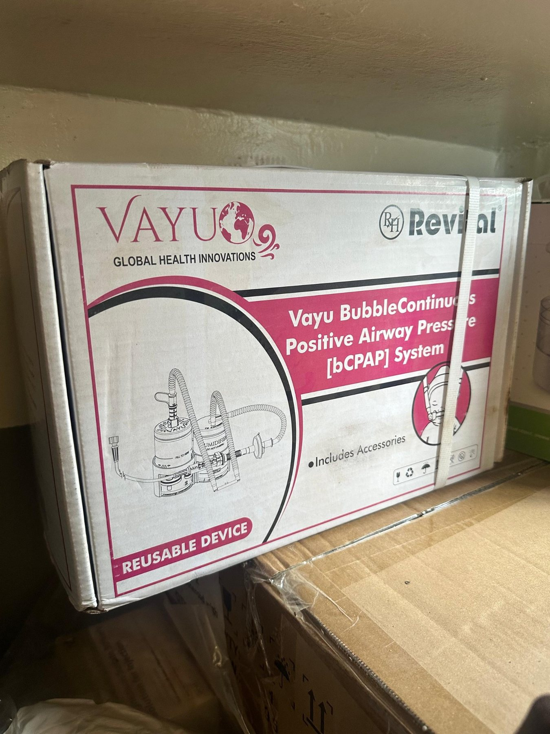
41 | Avogera Health Facility | 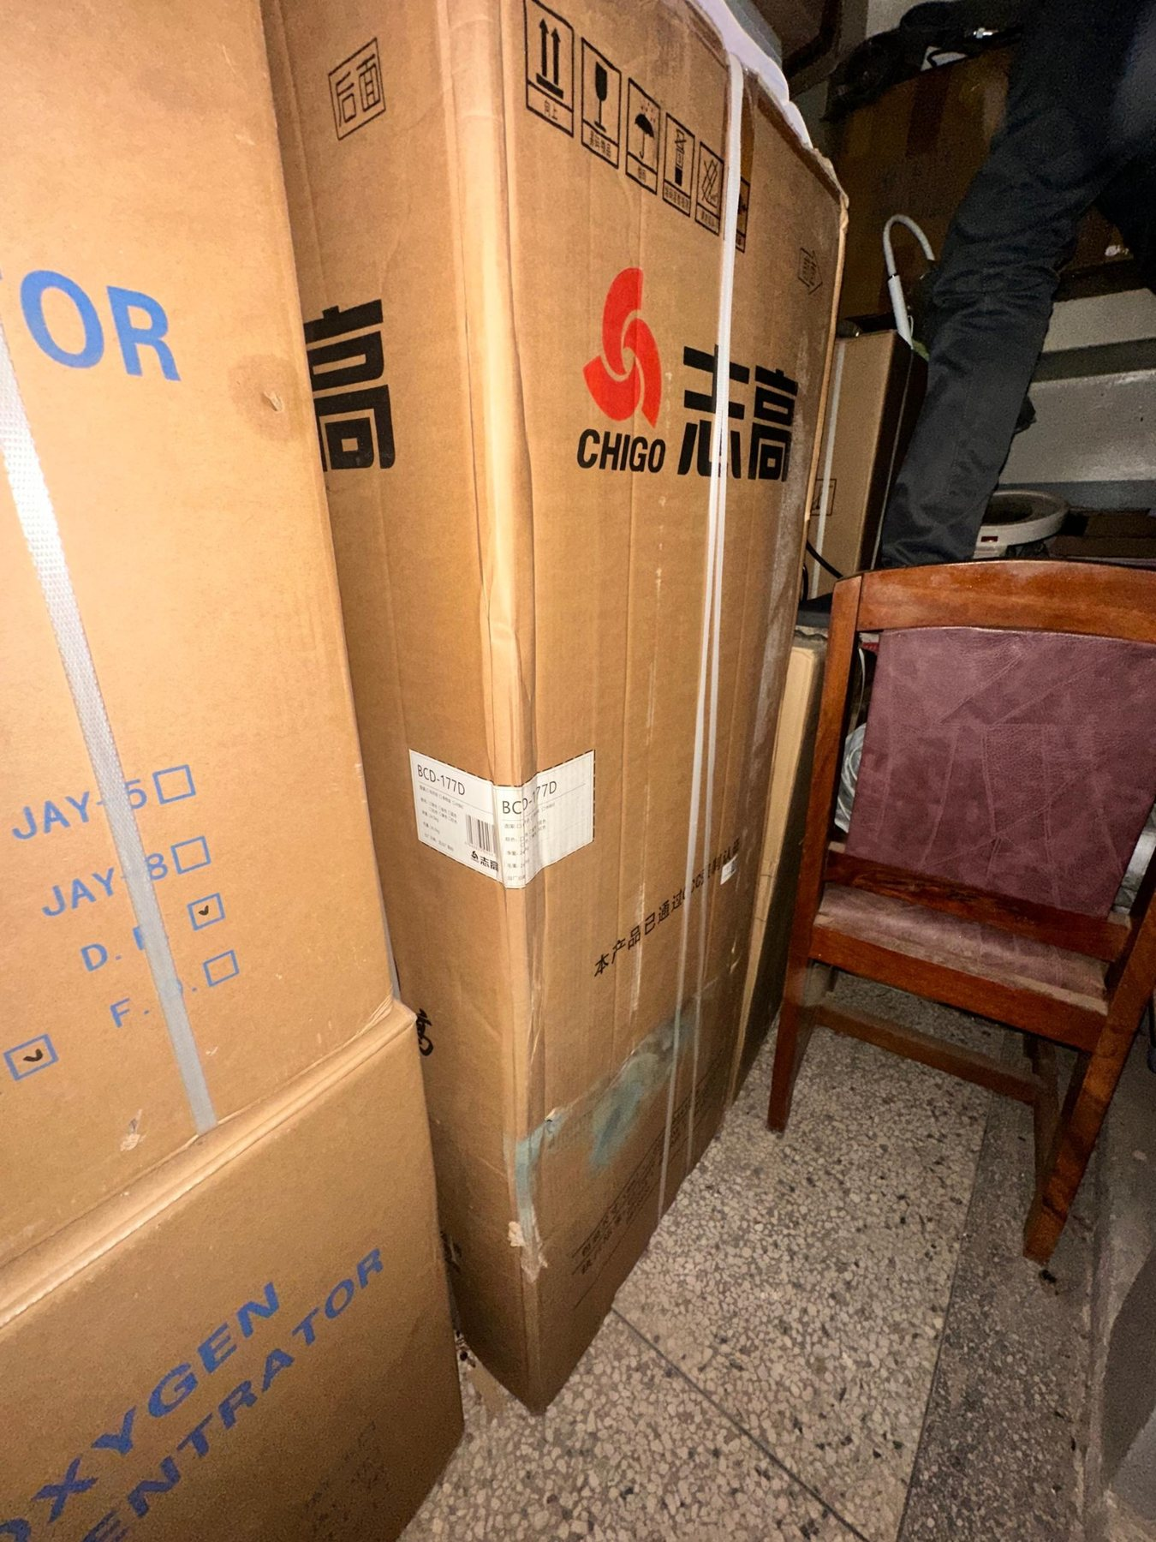
42 | Avogera Health Facility | 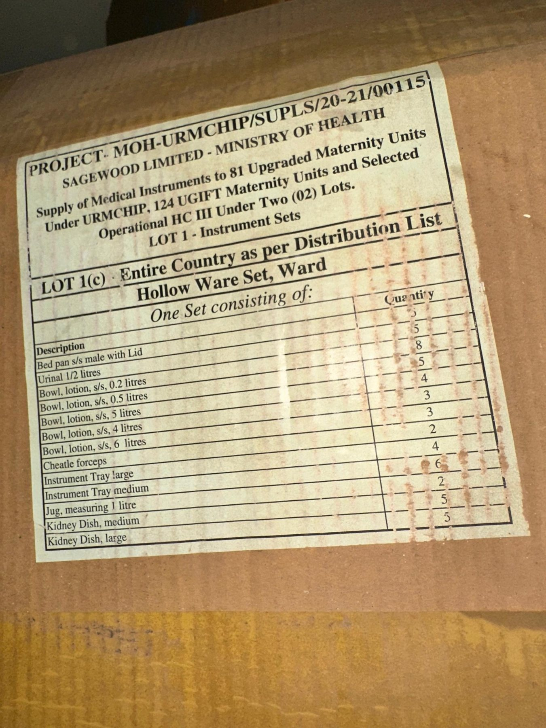
43 | Avogera Health Facility | 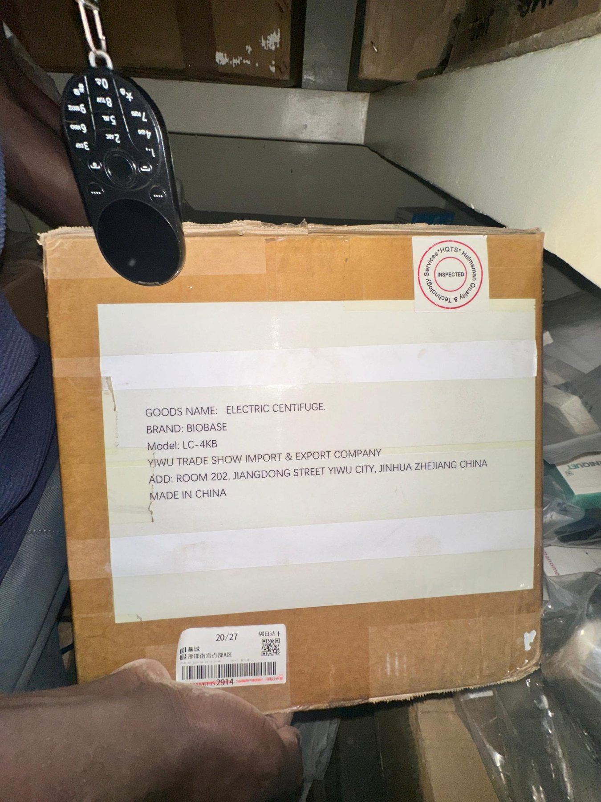
44 | Avogera Health Facility | 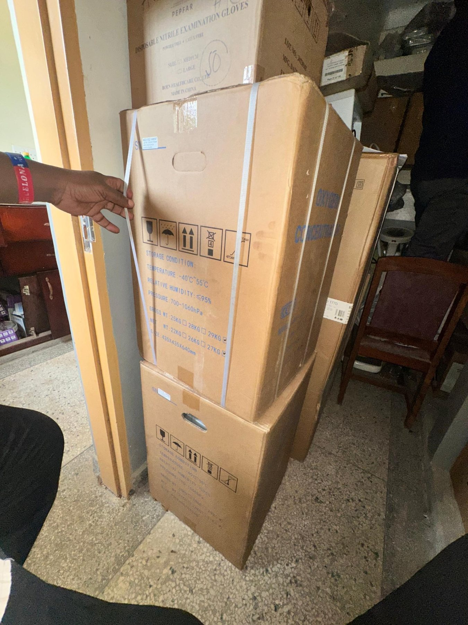
45 | Avogera Health Facility | 